Life In West Hartford

Tracey M. Wilson

# Preface



This book-in-progress was last updated on: 2018-06-24

These chapters help tell the story of the West Hartford, Connecticut community from first settlement to the present day. How does the identity of a community grow? Who are the people whose voices have not been heard? And how did the powerful use their voices? Who spoke and worked for equality, democracy, justice, rights and rebellion, all ideals delineated in our Declaration of Independence? Local history gives us a window into how life in a democracy works.

## Introduction

Who tells our stories? And what do these stories tell about what we value?

For 15 years, I wrote local history essays for the magazine, West Hartford Life. I’m not sure how I wrote more than 130 essays, each at least 1,000 words, while I was raising a family and teaching high school history full time. These monthly articles continually put me in the position of my Conard High School history students - a deadline, a topic, establishing a context, evidence, and ferreting out cause and effect. This work helped make me a better teacher and community member. I was able use my historian skills at the local level to help community members examine who we are as a town.

As I wrote these articles, and as you read them, individually, and as a whole, think about how they define what we value as a community. What events included all types of people? Which events excluded people? Which reinforced who had power and which gave power to those who didn’t have it before? Whose voices were heard? What documents can give us a window into the past? Is the story about an individual or is it more about the context in which this individual lived? How do present day issues help to define what we want to know about the past?

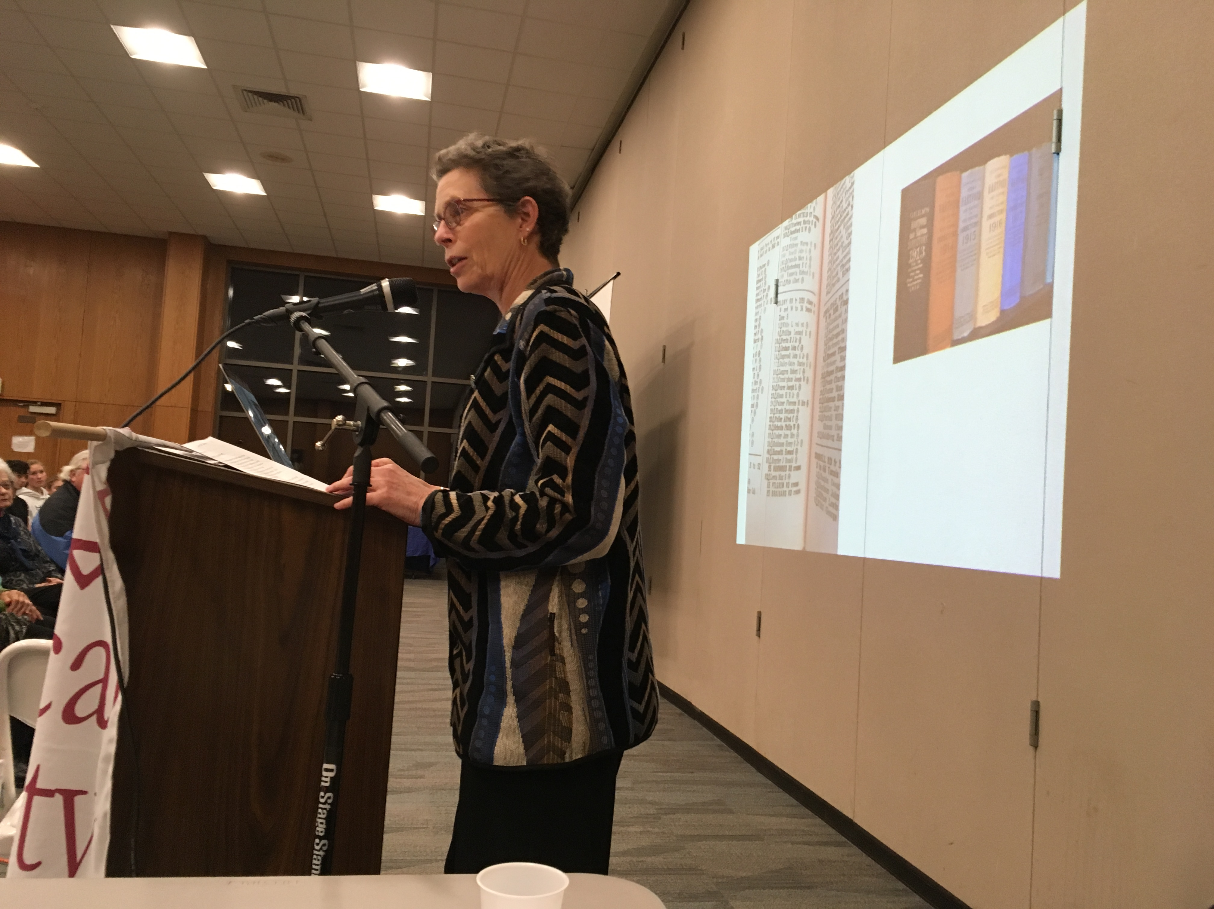

Author Tracey Wilson. Photo by Jack Dougherty

My love for this town comes from the involvement of so many citizens in striving to build a better community: a place based on justice, equal opportunity, a desire to join together to attack problems, and a love for those who live here. That is not to say that our actions in this town are always just, or that there is equal opportunity for all. Not everyone is a joiner, and not everyone is loved. But I dare say that many in this town make it their work to move toward those noble goals. You will read here about equality and differences. For example, you’ll read about our first meeting house, Lemuel Haynes, Amos Beman, Thomas Barrows, when we became our own town, Edith Beach, Susie Butler Andrews, Dr. Caroline Hamilton, the League of Women Voters, attempts to build affordable housing, Korczak Ziolkowski, Soviet Jewish emigres, school Superintendents, people who died in the many wars, and about pioneer Olivia Shelton.

Former Connecticut State Historian Chris Collier argued that he could teach United States History by teaching Connecticut history. There is much to be said for that sentiment. For the stories here about West Hartford teach us about equality, democracy, justice, rights and rebellion. Local history, too, can teach U.S. History.

## Acknowledgements

So many people have helped me become the historian and community member that led to this book. I think of my high school history teacher, Pete Lynch from Granby Memorial High School, college professors Jim Miller, Kim Steele, and Joan Hedrick from Trinity College. Graduate school professors Mari Jo Buhle and Joan Scott each helped me find my voice.

As a teacher, my department supervisors at Conard encouraged and supported me in teaching a Local History course, and did so for over 20 years. My students taught me much about what mattered and what stories had staying power. Thanks too, to the Town of West Hartford, and Mayor Jonathan Harris for naming me Town Historian in 2004.

[West Hartford Life](http://www.turleyct.com/west-hartford-life.html) provided a motivation and venue for my work. Thanks to Mark Jahne and others who encouraged me. And thanks to TurleyCT Community Publications for permission to publish the over 140 articles that first appeared in their magazine.

I especially want to thank Prof. Jack Dougherty, who, when I was at a very low point, came to me asking if I would be interested in making the articles into an online book. Jack made things happen. His intern and my former Trinity student Vianna Iorio did much of the legwork to help me get the articles in order and provide searchable words, a short synopsis and a means to organize them. What a treat to have them both help me through a difficult time and keep me motivated. Thanks for their friendship and professional help, especially when I needed it most.

Thank you to the Noah Webster House and West Hartford Historical Society, especially Jenn DiCola Matos and Sheila Daley. Sheila had the knowledge and the skills to help me find the primary sources which appear throughout the book. And she helped me find the illustrations and embedded them in the text, no small task. Thanks to the West Hartford Public Library, and especially to Martha Church who always encouraged me in my study of Local History. Her knowledge of the town is vast and she has documents at her fingertips. Their Local History Room keeps the power of local history alive.

Thanks on a personal level to Liz Devine. We taught together for 37 years at opposite ends of town, for most of it, and then we retired together. We continue to talk history and teaching as we write curriculum and train young teachers. She is as good a friend as you’d ever find!

And finally, my family - Peter, Adam, Brittany, Caroline and Billie - who delight in my love of history and find ways to keep me guessing. And, to Beth, who is the best partner a person could ever have and my best editor. She is supportive, fun, and curious, and she knows what I love. *– Tracey Wilson, June 2018*

# Colonial Life

## Equality and Difference in Colonial West Hartford

*Originally appeared in West Hartford Life, November 2000*

“All men are created equal.” This grand statement appears in the Declaration of Independence written in 1776. Since the writing of the Declaration, Americans have thought a lot about the issue of equality in political, economic and social terms.

Was there equality in the West Division of Hartford (as West Hartford was called before independence in 1854) by 1776? And, did colonial residents recognize economic and social differences?

Landholding is one place to look for differences in wealth. When the proprietors divided the West Division land into long lots in 1671, they distributed it according to how much land each man owned in Hartford. Those who had large lots in Hartford received large ones here. There was no attempt in the move west to equalize fortunes; instead this land division reinforced the economic hierarchy that existed.

At the same time, more Americans had the chance to own land than in England. Proprietors divided the abundant land among all sons in the New World, as opposed to only the first son in England.

A look at colonial homes still standing in town gives a glimpse at the range of house sizes and thus the resources of individual families. A middling farmer built the Noah Webster House at 227 South Main. Built around 1748, the house originally had four rooms built around a center chimney. The Benjamin Colton House (c. 1770) at 25 Sedgwick Road and the John Wells Jr. House (c. 1766) at 505 Mountain Road both are substantially larger than the Webster House. They have five windows in front and two on each side, while the Webster House has three windows across the front and one on each side.

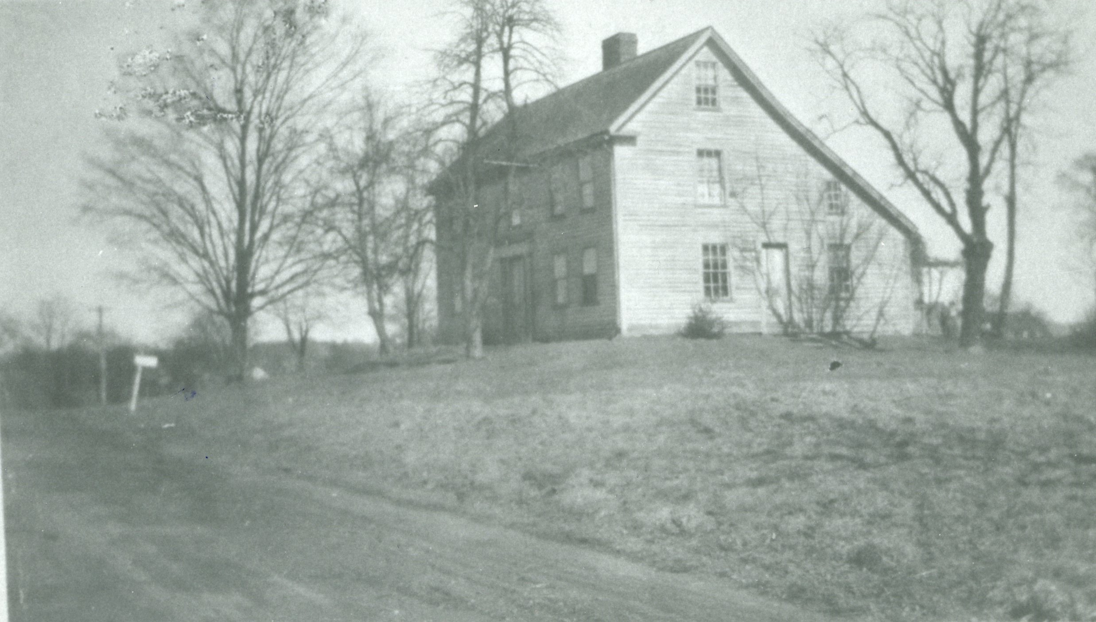

The Gillet house, at 202 South Main Street is one of 18 remaining colonial homes in town. It was built by Asa Gillet, a grandson of Joseph Gillett, one of the first proprietors of the town in 1694. Asa Gillett farmed both sides of Main Street in the late 18th century and he traded with the merchant Joseph Webb in Wethersfield. Source: Noah Webster House & West Hartford Historical Society.

This comparison tells us only so much, however. The houses of the poorest residents did not survive. Those who had not reached the middle-class status of the Websters might have lived in a cellar with a roof, or in a shack that did not withstand more than a few winters. Archaeologists in other New England towns have found the remains of such buildings. We have no sites or artifacts here because larger homes were built over these original, simpler structures. But we can hypothesize that the difference between rich and poor housing was greater than the examples left standing.

Inventories taken at the time of a man’s death, are another way to assess the difference in wealth among West Division residents. Designated townspeople went into the deceased person’s home and listed everything found in each room. Today these inventories can be found at the Connecticut State Library. In the 1770s , the total value of the inventories of eight different West Division families (featured in Noah Webster House educational programs) ranged from about 300 pounds to 1,300 pounds.

The types of goods owned by these farmers did not vary greatly. Most families had a Bible and perhaps one other book in their inventory. Wealthier families had more clothing, more looking glasses and more books. The biggest difference in wealth was the amount of land an individual owned.

The Rev. Nathaniel Hooker, the second minister in town (1738-1770) who died at the early age of 32, had a list of books and drugs appended to his inventory, showing his educational background as both a minister and doctor. Though his estate was worth only about 550 pounds, Reverend Hooker had the most social prestige in the town because of his education and his position as minister.

The presence of slavery in the West Division was a clear sign of inequality. At least 15 families owned people of African heritage between 1738 and 1827. We have the names of more than 40 people who were owned. Some bought their freedom, some were freed by the 1784 gradual emancipation law, and some died in slavery. Reverend Benjamin Colton owned what he named a “negro servant,” and Reverend Nathanael Hooker owned a man, a woman, and a child.

Finally, the use of church records can tell something of the social structure within the town. In the late 18th century, there was but one church in town: the Fourth Congregational Church of Hartford. All townspeople had to belong to the church and paid taxes for its upkeep and the upkeep of the town. These records reside in the John P. Webster Library in the First Church (so-called after West Hartford became an independent town in 1854).

In a First Congregational Church booklet from 1913 commemorating the 200th anniversary of the church, there is a description from the 1760s about how people were seated in the church. A church committee assigned those with the highest social, political and economic standing to the pews in the front. Church leaders designated a pew for “old maids” in the back of the church. African-Americans like Page and Lew and the widow of Jude (listed as Negro) were members in full communion of the church. They also sat in the back.

People knew where they ranked by their seating in church.

In a list of “Members in Full Communion” in December of 1764 from the Fourth Church, the only church in town, there is a clear differentiation between people by sex, race, marital status and social status. Titles such as captain, lieutenant and colonel distinguished military men. Leaders of the church were denoted as deacons. That Page and Lew were considered members in full communion at the church, however, is evidence that everyone could be full members of the church.

Gender defined social status as well. Married women, like “Stephen Sedgwick’s wife” were listed as wives, not by their own names. Women considered “old maids,” such as Lydia Smith, were listed with their given name and surname, but many widows were noted as Widow Gillet, without the use of a given name. Where you sat in the pews each Sunday reminded those church goers of the social and economic hierarchy of the church members.

In the 1770s, West Divisions residents saw the difference between rich and poor all around them. But the gap, in a small town like the West Division, was nowhere near as wide as it is today, where multi-million-dollar homes exist not too far from one-bedroom apartments. Yet the abundance of land gave more people the chance to be independent farmers and the chance at a higher standard of living than they would have in England.

And, even with the distinctions between classes, there was a sense of equality of access. All residents had to attend the Fourth Church. All of them traded with John Whitman and Zaccheus Butler. While they were reminded of their social standing in church every Sunday, they all shared the right to vote on church matters, and those who owned land voted on town matters. All West Division residents had certain basic inalienable rights, but they clearly knew their place within the established hierarchy of their small New England town.

## America Exposed as a Divided Society

*Originally appeared in West Hartford Life, October 2005*

Hurricane Katrina washing away the veneer of New Orleans, bearing the economic reality of American life, led me to reflect on our own community. How clear were the class, race and gender differences in the West Division at the time of the American Revolution? How did people separate and include one another in this community?

Economically, there was a clear difference in wealth in town by the second half of the 18th century. In 1766, Colonel John Whiting, former Treasurer of the Connecticut Colony, died at age 73. He was cited as the wealthiest man in the West Division. He lived north of Albany Avenue. In April 1768, Timothy Goodman’s house burned to the ground. The Connecticut Courant reported that the house “was entirely consumed, together with all his household furniture, clothes, &c. which were very rich and costly, about 200 bushels of grain, and a considerable sum of money.”

These same men who were amassing wealth may also have had indentured servants and enslaved people and/or apprentices in town. Jude, enslaved by Stephen Sedgwick, ran away in 1774. Bristow bought his freedom from Thomas Hart and Sarah Whitman Hooker in 1775. Once the gradual emancipation act passed in 1784, a number of African Americans appeared in the church records dying in a pauper status.

A number of indentured servants and apprentices were part of the West Division community as well. In 1768, an apprentice about 19 years of age named Moses Cook ran away from Ashbel Wells. Cook “carried away a great coat, a good suit of brown cloth, yellow buttons and sundry other articles of cloathing.” By law, anyone who found him was forbidden from hiding or employing the runaway. Wells did not offer a reward for his return.

September 1784, an 18 year old named Truman Merrill ran away from Samuel Stanley. The advertisement in the Connecticut Courant said Merrill was about five foot ten and was well built with “short curl’d hair.” He worked Stanley’s clothier’s shop and Stanley believed Merrill would try to get work at this trade again. Stanley offered a reward of one shilling and sixpence.

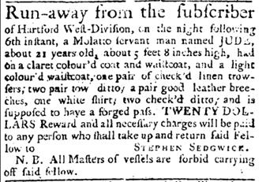

This Connecticut Courant runaway ad, August 9, 1774, is typical in describing what the runaway Jude was wearing and carrying. Note that Jude had a forged pass, indicating that either he was literate or he knew someone who would forge a pass. The owner, Stephen Sedgwick (1731-1792) married three times and had 10 children by his second wife, between 1762 and 1781. When Jude ran, Sedgwick was 43 years old and had 7 children. Source: The Connecticut Courant and Hartford Weekly Intelligencer (1774-1778); Hartford, Conn. 09 Aug 1774: 3.

In 1793, Charles Stedman, a lad of 18 ran away from West Division resident Francis F. Olmsted. A reward of two dollars was offered to the person who returned him. Olmsted described him wearing a London smoke coat, a stitched vest and brown trousers.

As early as 1791, there were ads in the paper about Charles Webster’s store where he had just received a fresh supply of European Indian goods, cloth and crockery ware. A customer could pay with “cash, country produce, tow cloth, linen check, clean cotton and linen rags,” all items produced in the West Division. In 1797, an ad for Webster’s store advertised that he had received goods from New York including broad cloths, plain and figured cashmere, flannels, vest shapes, chintzes, calicoes, satins, Persians, plain silk, and many other types of cloth. He also offered crockery, hardware and groceries.

The ability to trade for goods in the store is a sign that farmers could produce more than they could consume. Their production depended to a great degree on the amount of land they farmed and whether they also had a trade. Still, all 1,000 residents must have felt like they were part of the community.

The availability of land made life in America different than it was in England and spread opportunity around. Yet by the 1750s, land in the Connecticut colony was almost all being farmed. In 1754, Noah Webster, Sr. subscribed to land in Susquehannah County in the northern part of Pennsylvania. A man in Windham organized the subscribers. All the subscribers in the West Division lived near Webster on Main Street. Webster believed this land was controlled by the Connecticut colony because the charter gave the colony a right to all land westward.

The French and Indian War broke out in 1756 and fighting continued to 1761. In 1762, settlement began in the Susquehannah. In 1763, as a result of the Treaty of Paris ending the French and Indian War, the King in Council banned settlement on the Susquehannah land. There was concern among Connecticut’s political leaders about this land. Connecticut had an elected governor and by the late 18th century the citizens feared that this right would be taken away if they caused any trouble and the British in turn would appoint a royal governor like in Massachusetts. In 1769, opponents of of the Susquehannah land felt settlement there jeopardized Connecticut’s Charter which allowed for the citizens to elect their own governor.

The General Assembly replied in 1774, by extending Connecticut’s jurisdiction over the Susquehannah Company’s claim in the Wyoming Valley in Pennsylvania. Thus, those who had the means could speculate in land out west, increasing their wealth in relationship to those who could not invest.

Religion provided a sense of community in New England, but it was clearly a hierarchical community. The Congregational Church was the established church; all had to pay a tax for the support of the minister, and it was the only church in town until 1859. The first two ministers of the West Division were Benjamin Colton and Nathaniel Hooker. Both men graduated from Yale College. Colton graduated just 13 years after it was founded and became a minister in the West Division in 1714. He served for 46 years until 1759 and earned his fame as a solid preacher.

Nathanael Hooker graduated from Yale in the late 1750s and was hired straight away; he was known to be a brilliant man. He died young at age 33 in 1770. A 1764 list of members in full community at the Fourth Church of Christ Congregational revealed all levels of people who belonged to the church including a colonel, a lieutenant, several captains, deacons, “negroes,” widows, wives, and single women listed by their own names. Anyone could be part of this church, though within it, people’s ranks were clear by the seating arrangement, decided upon by the deacons. Women could be members in full communion, but widows sat in the back and wives were known by their husband’s names.

The Reverend Nathaniel Hooker understood that for women’s education, his community could not offer all he wanted for his daughter. For her, he felt, it was necessary to leave the community to get a good education. In his will he wrote that,

my said Daughter Ruth have a better and more polite Education than she can possibly have in the parish of West Division where she was born, and that for this purpose, She be sent to Boston or elsewhere as her circumstances will allow and prudence dictates, and thereby empower her Uncles James and Horace Hooker and her Aunt Eunice Ellery… [to carry out this desire].

For Ruth Hooker, the mores and services of the community would not allow her to develop in a way that her father envisioned so she had to leave.

The community in which she lived did delineate between people by gender, race and class. Clearly many of those divides could be considered even deeper in the late 18th century than they are today.

## The Rev. Benjamin Colton and the Great Awakening

*Originally appeared in West Hartford Life, February 2009*

The story of the Rev. Benjamin Colton, the first minister in the West Division, is a story of stability and tradition. He served the Fourth Congregational Church of Hartford here in the West Division for 46 years.

Settlers traveled to attend the First or Second Congregational Church on Main Street in Hartford when the West Division of Hartford was settled in the 1690s. By 1711, local residents wanted to have their own church.

When the settlers applied for a separate parish, there were 27 families with 164 family members here. According to their petition, seven houses had just recently been built, a sign that the area was growing. The petitioners claimed that there was enough land to support 90 families as they tried to make their case for their own church.

Connecticut’s General Court (now known as the General Assembly) granted the West Division the ability to have its own church, the Fourth Congregational Church of Hartford. On February 24, 1713, ministers in the Hartford area ordained Benjamin Colton to become the pastor of the new church.

Colton took on his ministry in the first meetinghouse. It was a plain building, built in 1712, at the site of the Veterans Memorial on the corner of North Main Street and Farmington Avenue. It was a square wooden, unheated building, with a pyramid roof, small windows, small galleries, a wooden pulpit and rough-hewn benches. This building served the church and the town for 30 years.

The new congregation had 29 members. To become a member of any Puritan congregational church, parishioners publicly confessed their faith. There were 12 husband-wife couples that belonged to the church as well as five men, one wife without her husband and a widow. This group was Colton’s first congregation.

Benjamin Colton studied for the ministry and graduated from Yale College in 1710. He was 21 when he took the pulpit. He was from a family of 18 children and grew up in Longmeadow, Mass. His grandfather emigrated from England.

Colton started as a trial candidate in his position until in October 1713, at age 23, when he was hired for a series of years. He married Ruth Taylor two months later. They had four children and in 1725 at age 32, she died. Colton was a widower for about one year. He then married Elizabeth Pitkin and they had five children. Elizabeth had her fifth child at age 47. This growing family became an integral part of the town.

Colton’s church grew in its early years, as did the population of the town. Not much is known about his preaching, as he only published two sermons. But he was clearly an effective leader, as the congregation kept him on and the church kept growing. The First Great Awakening in the 1730s increased his attendance even more, but led to controversy because Colton was not a supporter of this Great Awakening.

Colton was a religious leader in Connecticut. In 1737, he was selected to deliver a sermon to the newly elected representatives in the new state house that was built in 1719. In his “election sermon” he urged the legislators to get back to God by cleaning up their moral lives. He felt as though there were too many sins including “uncleanness,” pre-marital sex and the enormous amount of rum consumption, particularly among legislators. If, according to Colton, legislators were more moral, they could be more successful. Colton stood up for traditional values.

Even with his colony-wide stature, an outside authority had to come to settle things down at Colton’s church due to the intrusion of the Great Awakening. This religious revival tested the authority of Congregational ministers, their education and their message.

In 1734, Northampton’s Jonathan Edwards began the “awakening” revival, encouraging his parishioners to be more emotional in their faith and put their lives in the hands of God. Conversions were personal, but not public confessions.

George Whitefield’s revival tour in 1740 and 1741 caused a stir. The young English Episcopalian evangelist was emotional, enthusiastic and convincing at his first stop in Boston, where churches seemed unable to contain the crowds that came to hear him. He preached up to 16 times per week. Converts cried out, wailed and jerked their bodies and made the settled ministers uneasy. Whitefield preached in nearby Suffield, East Windsor, Hartford and Wethersfield. Colton and other settled preachers were upset with Whitefield’s invective against settled ministers who had not been taken up by the revival. He denounced their education at Yale and their lack of emotion in the pulpit.

Whitefield’s message was taken even further by the Rev. James Davenport of Southold, Long Island, who in 1742 vehemently denounced the Congregational ministry and in New London arranged for lay converts to burn the symbols of what he thought was wrong with material goods and symbols of learning, including their clothing, ornaments and books.

The Great Awakening moved many of Colton’s parishioners and Colton and Reverend Wadsworth in Hartford were both worried. But Colton remained in the pulpit, as officials from outside parishes came and settled things down.

The fact that Colton continued his ministry until 1759 showed that there was at least some victory for what were known as the “Old Lights.” His church remained the only one in the West Division until the Episcopal Church in the 1840s. However, it seems clear that he had to change his message to adapt to the ideas of the Great Awakening, even if he didn’t like it.

Colton’s tenure of 46 years at the First Church was a testimony to the importance of his traditional role of the ministry that he learned at Yale. There is no doubt that the Great Awakening jarred him and his fellow ministers, but with their mutual assistance, they sustained the monopoly that the Congregational Church had on religion in Connecticut for at least another 70 years.

## African-Americans in the 18th Century West Division

*Originally appeared in West Hartford Life, April 2001. The author thanks Sally Whipple, who collected these documents when she was director of the Noah Webster House.*

In 1893, Bernard Christian Steiner wrote the following in [*A History of Slavery in Connecticut*](https://archive.org/details/histslaveryconn00steirich):

In general, Connecticut has little to be ashamed of in her treatment of the Negroes. She treated them kindly as slaves and freed them gradually, thus avoiding any violent convulsion… Her treatment of the slaves was almost always kind and generous. A master, in true patriarchal style, regarded them as in truth a part of his family. With the coming of the revolution and the struggle of the Colonists for freedom, a feeling arose that it was not just to hold other men in bondage and as a result, importation of slaves was forbidden in 1774.

How much truth is there to Steiner’s assessment of the treatment of enslaved people in Connecticut? Were they treated kindly? Were the slave masters generous? Were enslaved people treated as part of the family and was the slave trade ended because of the ideology of freedom, which was so prevalent during the years leading up to the American Revolution? How did Steiner come to his conclusions?

The Public Records for the Colony of Connecticut, October 1774 reveal a far different reason for ending the slave trade in Connecticut than Steiner offers. “An Act for prohibiting the Importation of Indian, Negro, or Molatto Slaves” starts with the phrase, “Whereas the increase of slaves in this colony is injurious to the poor and inconvenient”… The legislators of the General Court in Connecticut were moved more by economic and political or moral reasons.

From the point of view of lawmakers, enslaved people took work away from the poor. Each town was responsible for taking care of the poor and the more enslaved Africans there were, it seemed, the more white poor there were. When legislators ended the slave trade, they acted out of their own self interest more than out of their commitment to liberty for all.

“Run-away” advertisements from the Connecticut Courant reveal that many enslaved people chose to flee rather than serve as a slave. In August 1774, Jude ran away from Stephen Sedgwick, a resident of the West Division of Hartford, now known as West Hartford. Jude was described as a “molatto servant man . . . about 21 years old, about five feet, eight inches high.”

In the West Division, enslaved people were sometimes called servants. Stephen Sedgwick’s probate record confirms that Jude was owned; he is listed in the record as “my Negro Boy Jude” on the line just above “all my sheep and all my swine.”

Perhaps one could argue that Sedgwick was generous to Jude. Jude ran away with a claret-colored coat, two waistcoats, three pair of trousers, a pair of leather breeches and three shirts. He traveled with a forged pass.

Whether Jude wrote the pass, we do not know. Masters describe their property carefully and knew their clothing down to the type of buttons. His wardrobe leads one to believe that Jude was not destitute, but despite Sedgwick’s generosity, Jude reacted in a way that questions whether he was being “kindly,” and “as a member of the family.” The owner offered a $20 reward.

There is some evidence of good treatment in the church. John Whiting owned Page, who was listed in the Congregational Church records as a member of the church. Page also had economic power. During the winter of 1740-41, he bought cloth, thread and stockings from merchant John Whitman as recorded in his account book. These transactions lead us to believe that Page actually earned wages and had some economic autonomy. Perhaps this is an example of the master-slave relationship Steiner was describing.

Steiner’s definition of a stable system based on family loyalty was put to the test in the 1790s. With the African uprising and revolution in Haiti between 1791 and 1794, Connecticut residents grew more nervous about the possibility of a slave revolt.

A newspaper article from the Connecticut Courant on September 19, 1791 reported on the “Insurrection of Negroes” in which the Negroes “destroyed all the plantations by fire; that they massacred without distinction every white man in their power; that Negroes are in immense bodies; that they have cut off all communication with any part of the country.”

The newspaper reported that the U.S. sent boats to Haiti to rescue the white women and children and to send them to Jamaica or Cuba. Seemingly the fear of slave revolt had to be stronger in the South, where in a state like South Carolina, there were counties with more than 75% African slave population. Connecticut’s slave population made up only about 3% of the total population.

However, in an alarming run-away ad in the Courant in 1794, Charles Churchill, a Wethersfield resident and owner of Jack, “a yellowith Negro who speaks French, Spanish and broken English” declared that Jack was a “cunning, wicked, blood-thirsty fellow who drawed his knife and cut a gentleman.”

Churchill went on to lambaste the legislature’s gradual emancipation act of 1783 because he believed freedom would only encourage freed men to cut the throats of the white people, “which would shortly be the consequence as hath been the case in the French islands, where thousands of white people have been cruelly murdered by the same act of liberality.”

This reaction does not seem like the actions of a slave or slave master who had a generous paternal relationship with the slaves as Steiner argues. Joanne Pope Melish in her book, Disowning Slavery: Gradual Emancipation and Race in New England (1998), argues that before the Civil War, New England’s leaders were pushed to establish an ideology in opposition to that of the South which requires them to forget about their oppression and exploitation of African-Americans.

Bernard Steiner must have used sources of slaveowners, not the enslaved to write his history; diaries of whites, not run-away ads, to establish what seemed like a beneficial relationship for both slave and slaveholder.

A look at 18th-century primary documents reveals a world of tension between owner and owned. Personal rebellion on the part of the enslaved instilled fear in the slaveholders trying to uphold this economic, political and social institution. The West Division was not immune to these tensions.

While all people understood the concept of freedom, not all experienced it.

## Whitman on Slavery

*June 2018*

This list was written on the back of a note about a mortgage deed sent to West Hartford’s Town Clerk, Henry C. Whitman (1864-1952), sometime between 1901 and 1914. This is just part of the document penned, most likely by Whitman, which lists all “negro” Baptisms, Owners of the Covenant, Members of the Church, and Deaths, gleaned from the pages of the First Church of Christ West Hartford’s vital records.

Whitman found that between 1738 and 1827, as many as 50 people of African descent lived in the West Division of Hartford (now West Hartford) and most of them were enslaved. Bristow Middle School (2005) commemorates one of those men. Bristow was part of a larger community of what were denoted in Church Records as “negro servants.”

At the Noah Webster House archives, in the Whitman Collection, you can find this 7 inch wide by 6 inch long legal letter, folded once. The letter has no date and fewer than 50 words. The letter reads:

Town Clerk, West Hartford, Conn.

Dear Sir:- Enclosed find a mortgage deed from Henry A. B. Day to this Company of certain property on Westland Avenue, which kindly record and return to us, together with your bill for recording. Yours Very Truly ,

C?? P. Day Secretary

Enclosure

When Town Clerk Whitman received the letter, probably in the early 1900s when Westland Avenue was being developed by Henry Day and his father’s construction company, he filed the mortgage deed and kept the note on his desk.

Then Whitman used the piece of paper to record what had been lost from memory, and possibly what he thought was lost from the story of the town’s past. Whitman not only copied them all out, he analyzed what he recorded.

Many West Hartford residents are surprised to learn that so many people of African descent in the West Division of Hartford were owned by town leaders, ministers, and the wealthier sorts and that so many enslaved people lived here. In 1790, at the time of the first census, there were close to 1,000 people who lived here, in about 150 families. Of those, at least 25 of these families – as many as 15% – owned people of African descent at some point in their family’s history.

On the back of this letter, under the heading “Slaves in West Hartford - from church records,” Whitman wrote out the names and made these categories:

* Baptisms
* Owned the Covenant
* Admitted to Membership
* Deaths

He listed the names from the church records under each of these headings, documenting men, women and children who were enslaved between 1738 and 1827. In all, Whitman wrote,

Record is found of some 30 or more actual slaves, or freed slaves 1738-1827. At least one saw war service, or something approaching it, “Prot.” who died in camp at Ticonderoga.

“Prot.” is listed under Deaths with the following note: “1776 Sep – Prot. servant of John Whitman, Jr. in ye Camp Ticonderoga.” Here Henry must have stopped when he wrote his own surname, Whitman, realizing that John was his ancestor.

The first in the list is Hannibal, negro servant to Thomas Hosmer, baptised in 1738. Thomas Hosmer was the grandson of one of the first proprietors, also Thomas Hosmer, who owned at least 300 acres north of the center. Just north of where the American School for the Deaf is today, his father, Stephen Hosmer, built the first mill in town. Stephen, according to Town Historian Nelson Burr, “became one of the richest landlords, farmers and traders in the Connecticut Valley.” He became a communicant of the Fourth Church of Hartford in 1725 under Pastor Nathaniel Hooker. He married Susanna Steel in 1734. According to Whitman’s notes, his “negro servant Hannibal” was baptized on November 5, 1738. Five months later, in April 1739, Thomas and Susanna had their first child Thomas who was baptised. In 1742, Thomas bought a second man, “Hercules (Negro serv’t of Thomas Hosmer),” who was baptised in that year.

In 1742, Thomas was chosen Moderator of the church and re-elected through the 1760s. He was one of the citizens voted to take care of the schools, and to help build a new school house. In 1757, he took on the label Esq. In 1761, Whitman catalogued under “Deaths,” Feb. 24 Hercules (Negro Serv. to Thos Hosmer), age 32.

In January 1777, Thomas Hosmer wrote his will and died in that same month. In his will, he freed Hannibal:

I have given my negro Hannibal his home and yet by the law he may be chargeable to my Estate if he shall be impotent and unable to provide for himself, if such a thing should happen I order my six sons to provide for his prosperity in equal proportion, but if he be lazie and idle and spend his time foolishly I desire that they will take care that the selectmen will bind him out.

The church records reflect his status as a free man by listing Hannibal’s death as transcribed by Whitman:

1779 July 13 Hannibal A Negro Man Old Age

We don’t know if Whitman actually saw that Hannibal had been freed in copying out these records, if he hadn’t seen the will. But one piece of his analysis leads us to believe he did:

If Thos. H. Hooker was 1st to free his slaves Capt. Keyes seems [to] have been last. The negro slaves were apparently generally set free in West Hfd Parish at end after the time of the Revolution 1775-1791. In support of this conclusion is the term “negro man” instead of “servant” first recorded in 1778 + appears commonly after that.

Why did Whitman transcribe these records? Did he want to know that his ancestors owned Prot. and Rubin, a Black Boy? I wonder if he ever showed the list to anyone or if he shared the information with his wife, his children, or the leaders of the town? Was it only for his own edification, for his own understanding of the colonial world? We do know he kept the sheet and it made it from the church records to the Whitman Collection at the Noah Webster House.

Now the Witness Stones project will shine a brighter light on these women, men, and children who have mostly been forgotten. These men and women helped build our community and our churches through their work, yet, for so long we only recognized them as property here. Acknowledging the existence of this inhumane system of slavery is a first step in addressing issues of race in our community today. It must have been a jarring step for Whitman as well.

## The Sarah Whitman Hooker House

*Originally appeared in West Hartford Life, January 2005*

A house can tell a story. Take the Sarah Whitman Hooker house on the south side of New Britain Avenue east of Main Street. With its beginnings in 1720, it survives today as the oldest structure in the town. The house is owned by the town, but limited access to the house has not allowed its story to be heard by very many people.

The structure was built about 50 years after lots were first divided in the West Division. Split in the late 17th century, people started to move here after the fear of the Indians died away with the end of King Philip’s War (1676). By the 1680s, Stephen Hosmer built a mill on Trout Brook where it crosses North Main and owned 310 acres of land. In 1710 and then again in 1711, citizens of the West Division, 27 families and 164 people, petitioned and got its own church which became the Fourth Church of Hartford.

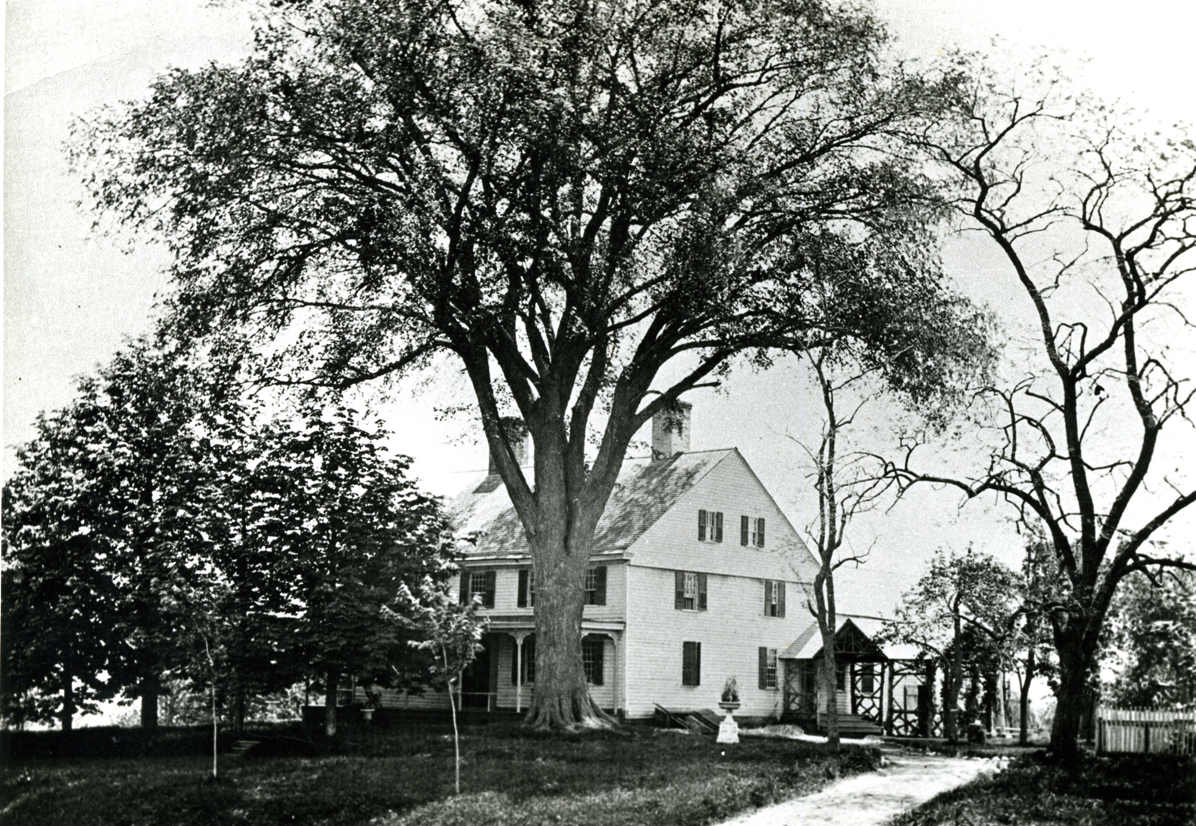

The Sarah Whitman Hooker House, 1237 New Britain Avenue, was built pre-1740 around a tavern room, probably the oldest section of a building in West Hartford. The home has been used as a tavern, a one family home, a prison during the Revolution, a boarding house, a restaurant and inn, and since 1976, a museum owned by the Town of West Hartford. Source: Noah Webster House & West Hartford Historical Society. Date: 1882

Ten years later, John Seymour purchased the land on which the house stands from Stephen Steel. In Seymour’s 1747 will, he mentions his “mansion house on Four Mile Hill in the West Division.” In colonial days this location was called Four Mile Hill – four miles west of the Old State House on the South Road to Farmington.

The structure began as one room with a chamber above and was probably first used as a tavern. Soon after, Seymour added onto it, making it a seven room house by 1747, at the time of Seymour’s will. Seymour’s son Timothy held a license for a tavern in 1733. Next to the meeting houses, the taverns were the most important centers of village life in colonial America.

In the mid-1770s, Sarah and Thomas Hooker moved into the house on the South Road. Sarah Whitman Hooker was the daughter of John Whitman, a prominent town merchant and political leader in the 18th century. The extensive list of household furnishings and goods which her father gave her on her marriage are enumerated in his account book and thus provide a glimpse into the material nature of her life. This account book can be found at the Connecticut Historical Society.

Thomas Hart Hooker went off to war in May 1775, right after the first battle at Lexington and Concord, leaving his wife and two children ages three and five. He died of pneumonia six months later during the siege of Boston.

Hooker’s slave Bristow bought his freedom before his master left to fight. It seems that Hooker also had a slave named Amboy, and according to an 1882 photograph American Revolution, the house was home to a slave named Amboy who planted an Elm tree on the property in 1769 (cthistoryonline.org). I question the date recorded on the photograph, because it wasn’t until 1777 with the first American victory over the British at Saratoga, that there was a systematic planting of Elms in the center of Elmwood by Capt. Ebeneezer Faxon.

There is no evidence of slave quarters at the house, but it is clear that Hooker owned slaves. Eighteenth century inventories seem to reveal that not more than one black lived on the premises at one time.

During the American Revolution, after she was widowed, Sarah Whitman Hooker was asked to “keep” Philip and his son Andrew Skene, Tories who were taken as prisoners. Hartford had a “Committee Appointed to Take Care of Prisoners” that received their orders from Governor Jonathan Trumbull. Hooker was charged to “confine him on his parole of Honor not to go out of the bounds of Hartford . . And provide. . .[him] with suitable lodgings and entertainment in some remote part of the town of Hartford.” Philip Skene was the Loyalist Governor of both Forts Ticonderoga and Crown Point in upstate New York. The Skenes were native born, not English soldiers. A report in January of 1776 claimed that over 20 people gathered outside the Hooker homestead to harm the prisoners. Purportedly, Hooker calmed them down and they dispersed.

In the early 1800s, Sarah Whitman Hooker added on to the house. She had the central chimney removed and in turn built twin chimneys on the east and west sides of the house. It is a typical five bay center hall Georgian style home, with clapboard siding and 12 over 12 double hung windows. One chimney has been rebuilt after it was destroyed by fire in the 20th century.

A man named Jedediah Mills lived there in 1807 while Hooker owned the house. He had a taverner’s license for several years in the early 1800s. Still, again in the mid-19th century it became a tavern under the name the Sheaf of Wheat.

In the 19th century, West Hartford remained a farming town. By the mid-19th century, farming became more specialized, particularly in dairy. Just to the north of the house, Charles Beach built his Vine Hill Farm and by 1900, the farm was famous for “baby’s milk.” The Hooker house, by then owned by the Beach dairy farm, was used as a boarding house for workers from the Vine Hill Farm.

By the early 20th century, West Hartford transformed into a suburb and the Beach family sold its farm in the 1920s. They donated a good portion of their land to the town in the form of Beachland Park in the early 1930s. Once the farm stopped producing, the Hooker house changed from the boarding house, to a restaurant and inn and that was known as the Sarah Whitman Hooker House.

By 1976, the town of West Hartford owned the house and leased it to the West Hartford Bicentennial Trust to be open to the public as a museum. It was renovated through the efforts of the Fran Fransson. Her recent death has left the house in the same trust under the behest of her children. The house is on the National Historical Register.

To interpret an historical home, usually the trust decides on a time period, and certainly this house has rich ties to the Revolutionary War period. At the same time, the changes in its structure and use tell much about the history of the town in the 19th and 20th centuries as well. If the house was open more, the citizens who own it could learn more of the richness of the story in three dimensions.

## Ye Olde Burying Ground

*Originally appeared in West Hartford Life, January 2002*

Historians have several motives when they analyze artifacts and documents. We try to get a good story from them, have them make connections among people, make them capture a moment, and show how they reflect change. A visit on an afternoon in West Hartford’s Old Burying Ground on 30 North Main Street will provide you with the best light to read the stones and a way to understand the connections and tensions between people in a colonial community.

In West Hartford’s Old Center Burying Yard, whose first burial was in 1725 and whose last was in 1868, there are differences in how the dead were memorialized, depending on wealth and status, gender, race, and era in which they were buried.

During the Great Depression (in 1934), workers for the federal government’s Works Progress Administration surveyed the 137 graves and recorded their findings. With today’s data base computer capacity, it is easy to make a demographic study of those 137 people (though there are only dates for 134). There are 64 women and 73 men recorded.

The statistics show that life was good in the West Division of Hartford, especially in comparison to what some had left in England, and what some of the first settlers had suffered in the early 17th century. Taken by decade, the most people died in their 70s. Once people lived to be 10, their chances of survival, and even living into their 80s and 90s, were quite high. Thomas Merrell, born in 1714, the year after the first church was erected in the West Division, died at age 100.

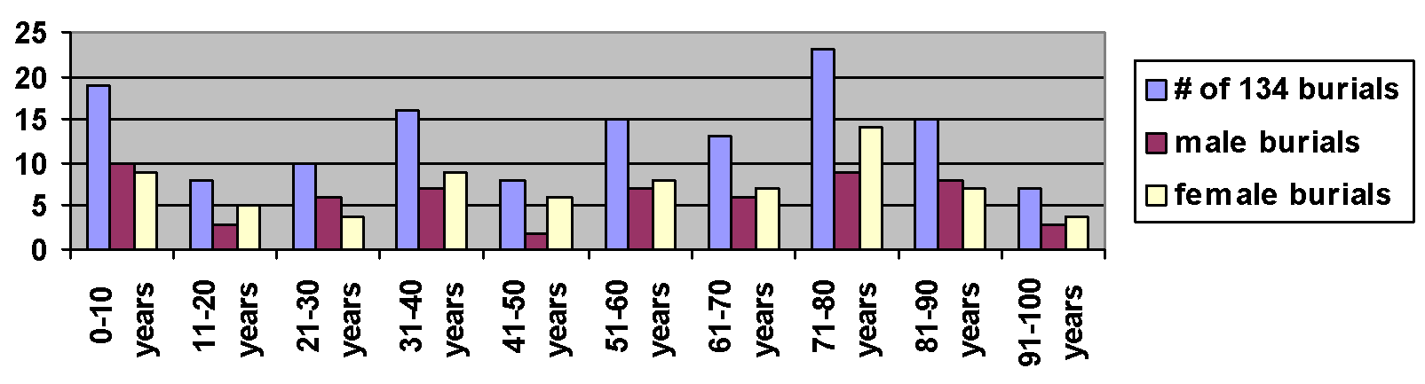

Old Burying Ground Burials, by age and gender

Today, more women live into their later years, but in colonial times, this seemed not to be the case, with more men than women living into their 80s and 90s. Many women died in childbirth. Rachel Webster, first wife of Abraham, (the oldest brother of Noah Jr.) died at age 21, in childbirth. Her infant was never named and died after 7 days. While more men than women died in their 20s, more women than men died in their 30s and 40s, perhaps showing that childbirth became more dangerous, the older the woman.

When you walk into the burial ground, you walk into the “new” section, which has burials from the 19th century. The old section, which is about two-thirds of the acreage, fills the northern section of the yard. You can immediately see a difference in the size of the stones. None in the old section are more than three feet high. The new section has two large obelisks that commemorate the Talcott (of Talcott Junior High and Talcott Mountain fame) and Stanley families. By the 19th century, the idea of individualism had made its way into American society and the large size of the tombstones shows that wealthy families wanted to distinguish themselves from others.

In the colonial section distinctions between the rich and poor are evident, but the difference is not as pronounced. Differences can be noted in the size of stones, the existence of a footstone and elaborate carving.

The largest stone, though, is not based on wealth, but on status in the community. It commemorates the death of Reverend Nathaniel Hooker who passed away in 1770 at age 32 after serving the Congregational Church for 12 years. His stone is the only tablestone in the burial ground, but is in a sad state of disrepair. The four pedestals collapsed a long time ago and are stored at the Noah Webster House. The bottom slab and the top of the table can be viewed in the burial ground. The full inscription on the “table” details Hooker’s contributions to the town and champions his role as the best-educated man in the community. He was known as a brilliant man who ministered well. His role as doctor, however, did not serve him well in that he treated himself with mercury, leading to his demise. This tablestone can be found in the center of the east side of the burial ground.

Men’s graves tended to be larger than women’s and more elaborate. Samuel Stanley, who died at age 38 in 1787, had both a headstone and a footstone and his stone is much larger than that of his wife, Anna, who died at age 33 in 1780. Anna had no footstone. This reflected women’s partnership with men, for they are buried next to one another, but also represents the patriarchal society in which they lived.

Only one African American’s grave is marked in the burial ground, though I believe more are buried there. A man by the name of Bristol has a gravestone standing alone in the northwest corner. His stone reads, “Bristol, An African, Died 1814.” It is a simple but powerful remembrance of a man who bought his freedom from Thomas Hart Hooker in 1776 and who gained a reputation for his agricultural knowledge in his adult life. West Division farmers often consulted him. However, he could not be buried “among” them, and he was only given one name on his tombstone. Like his membership in the church, his location was separate in the burial ground.

A walk in the Old Burying Yard brings you back to another place and time. But it also jars you with the underside of life in the 20th century. The gravestones are in a bad state of disrepair. Trees and weeds compromise the stones. Lichens grow. And the writing on many of the stones is no longer readable. Vandalism from 1990 when 34 stones were damaged has still not been repaired. Can we afford to leave this window on the past in such disrepair? What does this tell us about our connection with those who came before us?

## A Look at The Merrells

*Originally appeared in West Hartford Life, March 2002*

When Jacob Merrell died from an accidental fall on his pitchfork, his wife Mary Merrell was left widowed. She never remarried, and lived in the West Division until her death in 1792. Surviving as a widow at that time in history was challenging, as it was seemingly impossible to live as a single person in an 18th century household. Mary stands out because she seemed to do quite well as a widow, probably through the support of her seven children.

How did Mary do more than just survive for the 21 years after her husband died?

The Merrells lived on the Farmington Road, now known as New Britain Avenue on their farm where Wolcott Park is located today. Samuel and Jonathan Skinner, Joseph Skinner, Allyn Seymour, and Charles Seymour were her neighbors. At the top of the hill, on the corner of New Britain Avenue and South Main Street stood a one-room schoolhouse for the south end of town.

Mary grew up in Wintonbury Parish (now Bloomfield), and married Jacob Merrell in the 1750s. Jacob was 41 at the time of their first child’s birth. When Jacob died at age 57, he and Mary had four girls and three boys who ranged in age from 16 to 4. Mary bore children in 1755, 1757, 1758, 1760, 1762, 1766 and 1767. Thus was the life of a farming woman.

According to Blackstone’s four-volume legal code written in 1765, married women were literally “covered” by their husband’s authority. Her “very being or legal existence,” he wrote was “consolidated into that of her husband; under whose wing, protection and cover she performs everything.” As a married woman, Mary Merrell could not own or buy property in her own name, enter a contract or write a will. Once she was widowed, she gained some of these rights back.

We can get an idea of how Mary lived by comparing the probate record of Jacob Merrell when he died in 1771 with Mary’s inventory when she died in 1792.

Upon a husband’s death, wives received one-third of their husband’s wealth, called the “dower’s share.” The most valuable “movables” Mary received were a feather bed bolster, a year old heifer, curtains, a blanket, and six silver teaspoons. Each of these items was worth more than a case with drawer (a blanket chest with one drawer). She also acquired a bed, two pillows and two blankets. For her third of the farm, she got a one-year-old heifer.

She also received one-third of the real estate of land and house. The probate records described specifically what parts of the house legally belonged to her. Along with getting the South Lower Room, she also got the “liberty to use the fire place in the North Room for washing and baking and to pass and repass thro’ the entry North Room and Kitchen to the well.” She also got the west end of the barn and the liberty to use the barn floor for carting in hay and threshing and feeding the cattle.

Her oldest son Jacob, who was 13 at the time, owned the other two-thirds of the estate. What would it have been like for a grown woman to have to depend so heavily on her 13-year-old son?

Mary’s inventory on her death 21 years later provides a window on how she survived for those years without a husband. She kept many of the movable goods she received in 1771 and she added a large number of goods showing that, though she may not have prospered, her standard of living probably did not decline noticeably.

By the time of her death, when she was in her late 50s, she had items that reflected economic production, furniture and clothing, and items that went beyond the necessities.

There was clearly economic production in her house. Mary had a churn, Dutch wheel, and two hetchels for preparing flax to spin into linen. She had a few hogsheads and two meat barrels in which to store her food. She had one pig, two cows, and one steer. She had a right to the horse house and she owned 36 acres of land in her own right. She also had two hives of bees, which aside from her animals and land, were her most valuable property. Perhaps she got these hives during the Revolutionary War when West Division families chose to stop importing British traded sugar.

She had about the same amount of furniture, and had added blankets, quilts, another bed and several sheets. She had many more kitchen tools including a porridge pot, teapot, large basin, brass kettle, large iron kettle and a washtub.

Her ownership of a clock, two “best” tablecloths, five teaspoons, five napkins, and two pictures show the growing gentility of the age. The standard of living for all New Englanders improved over these twenty years, and Mary’s ability to buy or produce these items shows that she was able to improve her standard of living.

Her children were in their 20s and 30s by time she died. Some of them must have stayed to help her or lived nearby.

Mary had enough money to pay her funeral expenses which included, in order of value, a gravestone, money for the distributors, two quarts of gin, money for the surveyor, money for the advertisements, money for “time and trouble”, one quart of rum, and a horse and wagon.

Widowed farm women had to live with others to survive, and Mary Merrell had her children. She could continue to run the household and, in Mary’s case, her honey might have given her some extra buying power. Women could choose not to remarry, but my guess is that Mary’s 21 years of widowhood would have been remarkable in small town New England.

## Old Lights and New Lights

*Originally appeared in West Hartford Life, October 2003*

In 1977, local historian Elizabeth Hathaway wrote a “Chronology of some of the events that might have been discussed by West Division families during Noah Webster’s youth.” In this four page chronology of the years 1757 to 1774, she notes two particular events about choosing a new minister and buying and settling land in the Susquehanna which tie the reader to colonial and international affairs, illustrating how learning the history of our town, then the West Division, can teach about national and international issues.

Choosing a new minister was part of a web of larger events. The issues of fate, salvation, the role of the sermon, the role of emotions and good works were all part of the decision about who to choose as the next pastor. In 1759, Benjamin Colton, the first minister in the West Division, died. He served the town for 46 years and baptized Noah Webster, Jr. Colton trained to be a Congregational minister at Yale, and so was ordained by other ministers, not by bishops. Pastors from surrounding towns, including the First Church in Hartford, ordained him.

Colton held the beliefs of an Old Light minister, a man who supported the Puritan ideals of the colony’s founders. Old Lights had softened some of the strict rules of the church and the Halfway Covenant allowed more members into the church. The New Lights challenged the established Old Light clerical leadership who were trained at Yale. They emerged from the First Great Awakening in the 1740s. New Lights were considered more evangelical, and the sermon, which could move congregants emotionally, was more important than the reasoned sermons of the learned Old Light ministers. New Light ministers were not college educated, but were known for their ability to preach.

The Hartford ministry liked the revivals at first. They felt they breathed new life into their congregations. Itinerant preachers like George Whitfield – an outsider, without a Yale education - preached in the area. As the New Lights gained followers, the Old Lights condemned them. Local Puritan ministers refused to approve New Lights for ordination.

The Old Lights, like Benjamin Colton, supported the Presbyterian associations that were set up by the Saybrook Platform in 1708 which centralized the choosing of ministers to make sure that they were products of Yale and the traditional preaching of the Puritans.

New Lights wanted each church to have congregational independence. They accused Old Lights of believing that people could control their salvation contrary to the belief that their fate was established at birth. (Anne Hutchinson was kicked out of the Massachusetts Bay Colony in the 1630s for this idea that people had some control of their fate.) The Old Lights denied this, but the accusations stuck. New Lights said that the Old Lights examined people’s’ lives, not their hearts. New Lights opposed the rational, more intellectual teachings of Old Lights. These New Light evangelical ministers allowed congregants into their churches without saving grace and attacked Old Light ministers for being spiritually dead.

There must have been some discussion of these issues in the West Division upon Colton’s death in 1759. In that same year, there was an attempt to oust the Old Lights from control of the General Assembly which met in both Hartford and New Haven, but it was not successful.

In 1759, the West Division congregation elected Nathanael Hooker, another Yale graduate, thus affirming the Old Light control of their church. But the New Light presence did not disappear. Just seven years later, in 1766, a parish member invited a New Light minister into the group and it was deemed a disorderly thing to do. The influence of the First Great Awakening had West Division residents thinking, but their allegiance remained with the Old Lights.

A second issue which brought world issues to the West Division was Connecticut land claims in what had become Pennsylvania. The Connecticut Charter dating back to the 17th century claimed Connecticut’s land stretched from sea to sea. This led to overlapping claims with William Penn‘s charter, which most people agreed, superseded this charter. But, some people, especially in eastern Connecticut still believed they had jurisdiction over western Pennsylvania. The French also claimed some of this territory.

People in the Connecticut colony started a land bank where people borrowed and deposited money. The deposited money earned interest, and people put up Susquehanna land as collateral for the money they borrowed. The land bank invested in the Susquehanna land company. Speculators in eastern Connecticut had done so for years.

Noah Webster, Sr. subscribed to the land bank in 1754; he owned land there that would be bought by a settler. This land was disputed during the French and Indian War which endured from 1754 to 1761. When the war ended and the threat of the French and the Indians dissipated, settlement began in Susquehanna County, Pennsylvania.

However, the Proclamation of 1763, part of the French and Indian War peace treaty, banned settlement in the Susquehanna land. Webster’s investment seemed to have lost his value. But, in 1769, Connecticut residents, in direct opposition to both Parliament and the Pennsylvania colony, once again settled in the Susquehanna.

This settlement stirred up old tensions over Connecticut’s charter. Opponents of settlement, who tended to be Old Lights, felt settlement jeopardized Connecticut’s charter. They feared that this charter, which allowed for an elected Governor, not an appointed one by the Crown, would be in jeopardy if the settlers persisted. Connecticut was the only colony which did not have a Royal Governor, and the Old Light leaders believed Connecticut should lay low and not draw attention from Parliament in any way.

After Parliament passed the Stamp Act in 1765, New Lights took the principled stand of proclaiming the tax as evil. They questioned the Parliament’s ability to lay an internal tax and used this issue to unseat the Old Light Governor Thomas Fitch. Fitch had written a pamphlet on the issue, but he had not opposed the Stamp Act strongly enough. William Pitkin, a New Light, won election and took control.

Webster, Sr., aligned with the New Lights, while he lived in an Old Light town. Certainly there would have been those here who would have discouraged the speculation in Pennsylvania land. We can only guess whether Webster was making a political statement along with trying to make some money. We do know from Hathaway that Webster, Sr. was elected a grand jury man in 1760, and a selectman in 1768 and 1769, and from 1772 to 1774 he was elected Treasurer of the Ecclesiastical Society when Nathan Perkins, a Princeton graduate, became minister, upon Hooker’s death.

In the 1760s, tensions abounded in the West Division. These religious, economic, and political tensions were often tied to national and international events. The beauty of local history is that it provides specific evidence, familiar to us, that helps shed light on these broader events and ideas. The local and national events can each gain deeper meaning when we can make those connections.

## Here Lies the Story of Elisha Seymour

*Originally appeared in West Hartford Life, November 2011*

Elisha Seymour died at age 32 in October 20, 1776 of “the putrid fever” while serving in the West Division ’s militia to fight the British Revolutionary War.

He left an inventory of his “reale and personal estate” which allows us a window into the world of revolutionary America. By carefully reading Seymour’s inventory one can discover what he did for a living and something about his position in the community.

Noah Webster House researchers found Seymour ’s inventory in the Probate Records Collection at the Connecticut State Library. They searched through the Fourth Congregational Church records to find out how big his family was to try to recreate the texture of his life.

Elisha married Rhoda Sedgwick on June 13, 1762 when he was just 18 years old. Their first son Elisha was baptized just seven months after they married, a sign that premarital sex is not new.

Just 14 months later they had their second son. Rhoda and Elisha went on to have five more children, for a total of six boys - Elisha, Levi, Theron, Herman, Luther and Ambrose - and the last, a girl born in 1773 named Prudence.

When their father died in the war, their children were ages 2 to 13.

Seymour’s fighting in the Revolutionary War may have led to our independence, but what did it mean for Rhoda and her seven children? We don’t know how soon she remarried, but it would have been most difficult for her to survive on her own.

At age 13, it would have been difficult, but possible, for son Elisha to act as head of household.

Seymour’s inventory was used to appraise the total value of his estate so that his debts could be settled and his belongings could be fairly distributed to his heirs. The colonial court appointed appraisers, usually neighbors, to conduct inventories.

For Seymour, Daniel Webster (Noah Webster’s uncle) and Noah Webster Sr. appraised the property. Solomon Ensign and Benjamin Gilbert appraised a few more items that were tacked on to the end of the inventory, completed almost a year after his death on October 16, 1777.

Usually, the wife received one-third of the estate and the sons got the other two-thirds. Seymour’s entire estate was worth 257 pounds, 6 shillings and 10 pence.

He owned land, but probably not enough to be a farmer. He owned a house, three acres of land and a barn worth 140 pounds. This made up about 55 percent of the worth of his estate.

He also owned eight acres of woodland worth 33 pounds, about four pounds per acre. In the 1770s in New England, a middling farmer needed about 50 acres to make a go of it.

Seymour owned a yoke of oxen (10 pounds) and four cows (10 pounds) that provided him with a means for transportation and milk. He owned one draft chain and a narrow axe. He also owned a “chair carriage,” which likely was pulled by his team of oxen.

He owned seven stock sheep and two swine. He had two bushels of flaxseed in his inventory as well. Flax was used to make linen cloth.

Clearly, Seymour did not have enough land to make it as a farmer. Further down in his inventory, a set of shoemaker tools and a pair of boots is listed. He owned a shoemaker’s candlestick as well. So, he would have had a farm, but would have made a living as a shoemaker.

To process the wool and flax, Seymour owned two wool cards, a great wheel and a Dutch wheel for spinning. Cloth manufacturing was going on in his home, probably by Rhoda and the children.

In the kitchen, his household had a new corn basket and a frying pan. He had three old cider barrels and two hogsheads. He had a pepper mill, an old brass kettle, a box iron and heater, old knives and forks, a shovel and tongs, a pair of hand irons, a great trammel and a small, both installed in the fireplace.

He had two powdering tubs, three bottles, one stone jar, one coffee copper pot, a tea kettle and an iron pot. He had two great platters, five pewter plates, two pewter basins, a pewter teapot, three glasses, a china cup, a warming tan and a punch bowl.

The poor used wooden utensils, so the existence of pewter objects shows that Seymour did have the ability to show signs of gentility. Pewter cost about one-tenth of the price of silver, but still the cost of a dish equaled what a skilled craftsman could earn in a day. More than 300 pounds of pewter were shipped to the American colonies annually in the 1760s.

He also had eight earthen plates made by the local potter. He had a hand-held looking glass. There was a glass decanter and a glass cruet for vinegar. Seymour had an iron kettle and iron shovel for the fire, a pair of flat irons, which may have been manufactured in western Connecticut where an iron foundry was established in the early 1700s, despite British policy that no manufacturing could be done in the colonies.

In colonial homes, rooms had many different functions: Homeowners moved their furniture around daily. The best room where guests visited would also be the parental bedroom. Seymour owned two chairs, two feather beds and a second bedstead. a trundle bed and a bed quilt. He had three pillows and two pillowcases.

He also possessed woolen sheets. These woolen sheets could be a sign that Seymour bought locally woven woolen cloth. Cotton cloth was manufactured at this time in England, but Patriots like Seymour would have chosen not to import such materials during this time period.

He also owned linen sheets. Flax plants were grown right west of Webster ’s house down the hill in what is now Rockledge Golf Course. The two bushels of flax seed in his inventory point to home manufacturing of these sheets.

Before the invention of the cotton gin in 1793, flax literally sustained people in colonial America. It was grown in every colony. It was not only used for its fiber to make cloth. Fiber also was used for its linseed oil.

Seymour’s ownership of a tablecloth and curtains were a sign of the increased ability to produce cloth and the sign of a growth in consumerism.

Clothing was a valuable part of anyone’s estate in the late 1700s. Seymour had four coats, four vests, one pair of leather breeches and one pair of knit breeches. He had three pair of stockings, a new checked linen shirt , two plain shirts, a yard and a half of cloth, six pair of trousers, a silk handkerchief, a pair of gloves, a pair of shoes, a pair of shoe buckles and a pair of knee buckles.

He stored his clothing in a chest of drawers and a white chest. Seymour owned a gun and two powder horns. It is notable that he left a gun at home, because he probably had one with him while serving in the militia.

Seymour also owned two Bibles. He had a mariner’s calendar, a book called the Young Man’s Companion and an Old Mariner book. The shoemaker was both literate and religious.

Finally, he had a “note against Joseph Waters” worth 4 pounds 16 pence, 7 shillings. This note made him a lender, not a debtor.

Seymour made a living at one of the most commonly practiced trades in colonial New England. Because it was so easy to set up shop, the competition could be fierce and by the late 18th century, ready-made shoes from England were part of the competition.

With non-importation that came with the American Revolution, this could have helped him financially. Instead, he chose to go off to war.

Perhaps young Elisha had taken up the trade by that time. My guess is that family and maybe even the town had to step in to help Rhoda as she managed her household of eight without her husband.

## Textiles in Early West Hartford

*Originally appeared in West Hartford Life, February 2002*

Go see Lucy Young’s tablecloth and towel in the Noah Webster House’s exhibit “Textiles 2001.” The tablecloth is an “M’s and O’s” pattern made of natural linen. It is 23.5 inches wide and uses three panels of cloth. Woven sometime between 1775 and 1820, it has a hand netted fringe similar to fishnet attached on all four sides. Lucy Young signed her name to this tablecloth.

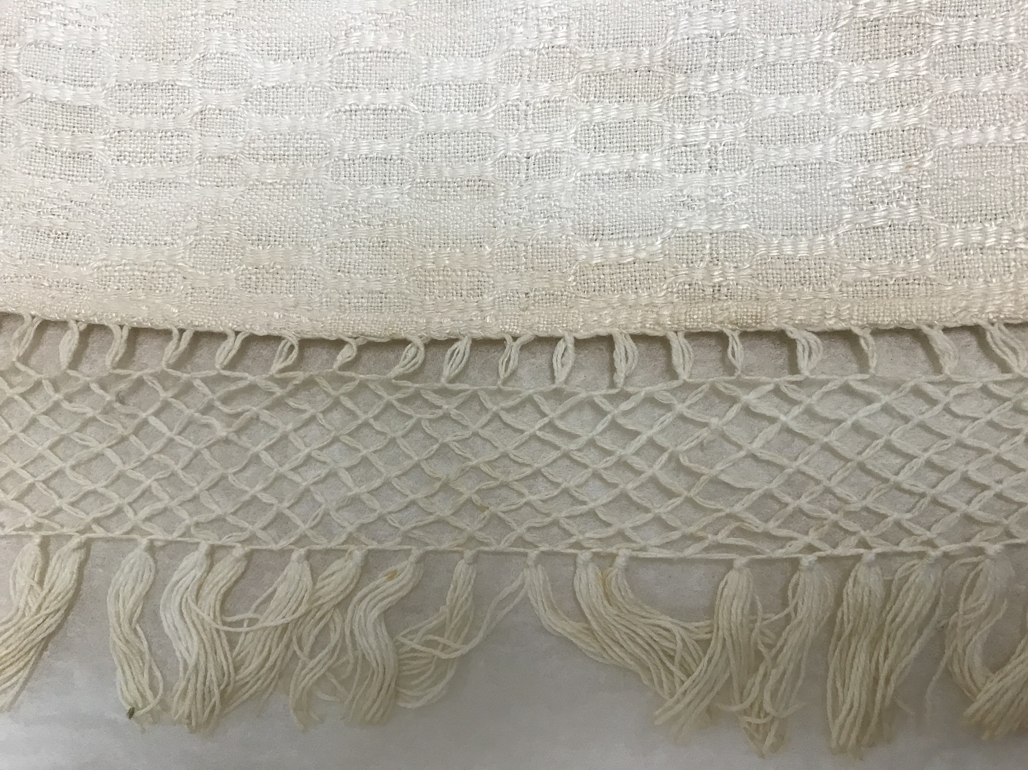

Lucy Young demonstrates her skill weaving natural linen using the “M’s and O’s” pattern. The fringe on the tablecloth denotes a sense of gentility in a growing consumer culture. It also represents women’s role in an economy based on work by both men and women. Source: Noah Webster House & West Hartford Historical Society.

You can also see a towel, known then as a “point twill diamond diaper” with a cotton tab on each end. This, too, was woven between 1775 and 1820 and belonged to Young. These pieces of woven cloth are beautiful to look at, and represent so much of the change and tension of life in a small town in Connecticut at the time of the new nation.

I happened to view these two textiles, among the 30 on display in the exhibit, while I was in the middle of reading Laurel Thatcher Ulrich’s new book, *The Age of Homespun: Objects and Stories in the Creation of an American Myth* (2001). Ulrich argues that textiles, as much as farming, were the center of the economy of the new republic in New England. When you find out how linen cloth was made, you get an idea of the interdependence of men and women and a feeling of the rising sense of gentility in places where people had been living for almost 100 years.

Ulrich, a Harvard history professor, uses a linen tablecloth from New Hampshire, very similar to the Lucy Young’s, as an example of household production. She argues that the edgings, tassels and fringes were a sign of “emerging neoclassicism and the spread of rural refinement.” She spends a chapter showing how this tablecloth reflects New England’s industrial beginnings, not as a radical departure from home production, but as an adaptation to what they already knew. She describes the interdependence of men and women in household production.

When we think about Lucy Young’s tablecloth within Ulrich’s interpretation, it gives us a new window on life in the West Division.

Local historians believe that flax was grown west of the Webster house, in what are now Rockledge Golf Course and the neighborhood that surrounds Duffy School.

Daniel Webster, grandfather to Noah, had a loom in his house. His inventory in 1766 listed one peck of flaxseed worth 1 shilling 3 pence, and 7 pounds of flax worth 6 pence.

Flax was planted in May by farmers who sowed the seed by broadcasting it. The seeds were light, but it was difficult to seed evenly. To plant a half an acre, farmers needed ¾ of a bushel of seed. In June, women often weeded the flax. Three or four days of harvest in late July or early August meant pulling the flax plants up by its roots, being careful not to tangle the stems. New Englanders let the plants grow long enough to produce seeds and the next step was to remove the seeds from the stem to save them for the next planting. Ulrich reports that in one Connecticut town, merchants exported more than 4,000 bushels of flaxseed in one year. West Division farmers probably produced only for local consumption. Daniel Webster’s flax seed was probably from last year’s crop.

The next step was to “ret” the flax to get the hard outer stem off the silky fibers. Interpreters at the Noah Webster house believe that this was done in the brook, which today flows through the golf course and then runs through a pipe under the Conard High School Athletic fields. Ulrich believes that many New Englanders retted flax in the fall by placing the flax on the grass where it would soak up the dew, until the outer shell broke down. Whichever method was used, it smelled terribly.

If you go up to the garret in the Noah Webster house you will see the tools used for the rest of the process. A “braking” machine swings a heavy plank onto a small bundle of flax and then a small paddle was used to separate the husk that remained. The short fibers called “tow” fell to the ground. Either women or men could have done this task. The husk was saved as tinder to start a fire; processing flax was often dangerous because of its flammability.

Hetcheling was women’s work and could be dangerous. Hetchels consist of a square of wood with an array of nails through which one draws the flax to prepare it for spinning. The Noah Webster House has three different sizes.

Spinning was a big part of women’s work in the early republic. Women spun alone and they spun in groups. They spun flax and wool. And they spun day after day.

Even as people were able to buy machine-made cloth from England, and as the industrial revolution began in New England, they continued to weave and spin. The consumer society, which we so easily recognize today, had begun. People had more textiles in their homes in the form of clothing, bed and table linens. But the home production continued. When 100 years earlier, a man might have two shirts; by 1800 he could have five.

In Connecticut, certain portions of the textile making were taken out of the home. By 1800, almost every town, including the West Division, had a carding mill. One was on Trout Brook in what is now Beachland Park, just north of the pond. No longer did women need to do the time-consuming job of carding the wool. People took their wool to the carding mill and it did this work very quickly. Then women had more time to spin. This did not mean that families got rid of their cards. Some total home production continued. In the 1759 inventory of the West Division’s Thomas Olmsted, one pair of cards is listed along with 15 ½ pounds of wool.

Inventories of Jacob Merrel (1770), shows him owning a weavers’ loom, a winding wheel, three shuttles and one hetchel. Allyn Seymour (1760) had a Little Wheel, a Dutch Wheel, linen yarn and worsted yarn. Ebeneezer Mix (1766) had 32 pounds of wool, some wool colored blue, a Dutch wheel, clock reel, hetchel and 34 weight of flax in his garret.

Mehitable Bidwell’s inventory (1767) shows the cooperative nature of the world 200 years ago. The inventory shows 1/3 of a hetchel, demonstrating that Bidwell had to share. Ulrich argues that ownership and cloth making were often community affairs.

The existence of Lucy Young’s table cloth, which is homespun, also tells of a new sense of gentility and the possibility of having more than what was necessary, another sign of the growing consumer culture. It is not until the 1770s that tablecloths begin to appear in inventories. By this time, people have the time and means to make what are not necessities. Allyn Seymours inventory (1760) lists two tablecloths, Ebeneezer Mix’s (1766) two diaper tablecloths, a fringe tablecloth, a birdseye table cloth, and a plain and a diamond tablecloth. Ebeneezer Sedgwick (1760) had a diaper tablecloth, two tablecloths, six diaper napkins, and four homemade diaper napkins. In this case, the distinction is made between machine bought and homespun.

These inventories and Lucy Young’s textiles remind us that men’s and women’s economic lives were interdependent. The household remained a site of production even as the industrial revolution began to move some production outside the home. This Industrial Revolution was not a sudden dislocation, but a slow process that was blended into the family economy providing more consumer choice and a higher standard of living.

## West Hartford Center

*Originally appeared in West Hartford Life, August 2009*

West Hartford Center’s vibrant mix of commercial, residential, religious, office and public buildings attracts many people each day. Even back in the 1770s, according to Elizabeth C. Hathaway, a local historian and researcher for the Noah Webster House in the 1970s, the town center from the Old Burial Ground south to Sedgwick/Park Road consisted of commercial, residential, religious, educational and public land.

John Pantry originally owned West Hartford’s Center in the late 17th century, according to Hathaway in her unpublished article ”A look at West Hartford in 1776.” In many New England villages, the proprietors made small house lots near a center meeting house but in the West Division, the land was divided in long lots from Mountain Road to Quaker Lane before there was a meetinghouse. In the late 1670s, when the land was divided, the proprietors expected that the residents would attend church in Hartford. It wasn’t until 1711 that the General Court allowed for a meetinghouse to be built in the West Division, and according to Hathaway, this is when the “center” began to take on an identity.

In the 1710s, the Ecclesiastical Society, the name by which the Congregational Church was known, bought land from John Janes north of the meetinghouse to establish a burial ground. According to the deed, Janes kept his animals there but had to maintain the fence around the land

Soon after the burial ground was established, the Brace family bought land abutting the burial ground. Probate records show that family members were paid to dig graves. The Brace family built the second mill in the West Division in the 1720s, right north of where Farmington Avenue crosses Trout Brook. If you walk in the Old Burial Ground, you can still see the lane that led from Main Street down to their mill. Sons of the first Brace mill owner, Zenas and Henry, operated the gristmill and lived on opposite sides of Main Street just south of the Old Burial Ground.

Citizens built the one room schoolhouse just south of the mill lane on the east side of Main Street.

Dr. Caleb Perkins lived across from the schoolhouse, and just north of the meetinghouse. He was a cousin of the Reverend Nathan Perkins.

By 1742, when the meeting house became too small for the increased population, Timothy Goodman granted land to the Ecclesiastical Society on which to build a larger meeting house. Goodman married a Pantry daughter and he gained ownership of the western section of land as part of her dowry. Goodman also granted land to the Ecclesiastical Society “for a place of parade forever.” Local men in the town’s militia trained at what today we call Goodman Green. Though the size and shape of the Green has changed in the last 265 years, it is still owned by the First Church of Christ Congregational and leased to the town for $1 per year.

The Ecclesiastical Society chose Reverend Nathan Perkins to be minister in 1772 after the Reverend Nathaniel Hooker died at age 30. Perkins served the church for 66 years. He purchased Hooker’s house on the east side of South Main Street and it remained the parsonage and stood until the 1930s when the new library and new Town Hall were built. Perkins tutored young men who had finished at the one room schoolhouse and wanted to attend Yale.

The Butler family owned land south of Hooker’s parsonage. Descendants of Joseph Butler lived on both sides of Main Street. John Whitman’s account book records the Butler family producing barrels, pails, wheels and plows on the land probably at the location of the Crate and Barrel and Radioshack today.

South of the Butlers, probably where the Town Hall is today, was the land of Abijah Colton, the son of the first pastor. He lived in his father’s house.

John Belden lived across the road and lived in what people in 1738 perceived of as “mansion home.” Belden also owned land west of Mountain Road on land that was then part of Farmington. He owned a share of a sawmill.

The Olmstead family owned the next pieces of land on the westside of South Main Street reaching to a point just north of Sedgwick Road. They were descendants of Nicholas Olmsted, one of the original landowners in town. His son Thomas inherited the land in 1683 and was the first member of the family to settle in town. In 1776, Thomas’s sons, Stephen (age 82), and Daniel (age 75) and his grandson Timothy and great grandson Nathaniel Steel, Jr. all had homes on the original property. Stephen had been a blacksmith and Nathaniel was a shoemaker. The land stayed in the family until the 1880s.

Ebenezer Crosby, Samuel Sedgwick, and Stephen Hopkins owned the land at the intersection of Sedgwick and South Main. On the northwest corner where the SNET building is today, Ebenezer Crosby ran his blacksmith shop. On the southwest corner, Samuel Sedgwick had his farm and his tavern. In 1714, he got a license “to give public entertainment for victuals and drink to sell at his house to people who come for ordination of their minister.” By 1731 his license included the “retail of strong drink and keep a house of public entertainment of strangers.” This is probably the site of the first tavern in the West Division.

Just to the west of this site, the Sedgwicks sold a piece of their land to the heirs of Reverend Colton. They built the colonial home which still stands today on the corner of Sedgwick and Ridgebrook Roads.

On the east side of South Main at Sedgwick, Samuel Sedgwick’s great grandson lived on part of the original farm and continued the weaving shop that had been there for two generations. He built another house and a tanyard that he worked into the 1800s. A tanyard was the part of a tannery that had the tanning vats to process cowhides into leather.

West Hartford’s town center in 1776 had mixed use. The third and fourth generations of the original owners had divided and subdivided the land, many carrying on the economic use of their elders. Weaving, tanning, shoemaking, blacksmithing, preaching, tavern keeping combined with farming provided for a lively town center.

Today, with West Hartford Center’s post office building on the list to close to save the federal government money in these tough economic times, it reminds me just how fluid the ownership of land in the center has been. While residents lament a loss of convenience, and a walkable service, and sign petitions to keep the small, but handy post office, both the federal government, and some local elected officials and developers yearn to develop this prime spot of land in the town’s center.

## Bristow: A man who bridged cultures, and bought his way to freedom

*Originally appeared in West Hartford Life, November 2004*

Bristow, an enslaved African aged 44, bought his freedom from Thomas Hart Hooker in 1775. Imagine the human dynamics of this manumission transaction. His manumission paper, in the Connecticut Historical Society, approximately 18 centimeters in length and of paper yellow with age reads:

Know all men by these presents that I Thomas Hart Hooker of Hartford in the County of Hartford for the consideration of Sixty Pounds money Rec’d to my full satisfaction – do by these present fully freely and absolutely release manumit and set at full Liberty a Certain Negro man Named Bristow from (?) to my house & assigns forever and I Do Grant to him said Bristow his full Liberty and Freedom from me and my Service that he may go & come when & wherever he pleases without any Hindrance or molestation from me or any one claiming from by or under me. In Witness whereof I have hereunto set my hand seal the 9th day of May Anno Dom 1775 in the 16th year of his Majesty’s Reign.

Signed, Sealed & Deli’v In presence of Thomas Hart Hooker Salmon Whitman Mary Root

Did Bristow know what freedom was while enslaved? Did he understand it once he had his freedom? His manumission paper clearly states what freedom included:

* Being at full liberty from Hooker’s house forever
* Having freedom from service to Hooker
* Going and coming when and wherever he pleased without any hindrance or molestation from Hooker or anyone claiming to be working for Hooker

When I study slavery with my students, I often ask if they think enslaved people can understand freedom. Some students argue that not having freedom allows a person to understand the concept better. Others say that if a person can see his/her master’s freedom, s/he can know what it is. Still others argue that a person can only know what freedom is when they have it.

Thomas Hart Hooker, the owner of Bristow, was 30 years old in 1775 at the time of Bristow’s emancipation. He was the great-grandson of Thomas Hooker, the first English settler in Hartford. Thomas Hart Hooker married Sarah Whitman Hooker six years earlier in 1769 and they had two children, Abigail, born in 1770 and Thomas Hart Hooker Jr. born in 1772.

At a point in time before 1775, Bristow had come to be the property of Hooker. This was not an unusual event in the West Division of Hartford. The pastors, Benjamin Colton (1713-1759) and Nathanael Hooker (1759-1770) each owned slaves. Africans who were enslaved were present in both Hartford and the West Division and most likely it was the economic and political leaders of the day who owned these Africans and their descendants who were often referred to as “servants.”

In December 1774, many colonists agreed to stop the importation, exportation and consumption of British goods. But even after the first battle of the war at Lexington and Concord April 19, 1775, most Americans believed that the British would change their ways. They remained loyal to England and thought that the Parliament would treat the colonists more fairly.

Hooker enlisted in the Hartford militia as a private soldier at “first call” in 1775. His wife, two children and maybe some other “Negro” servants were left home, but Bristow would have been free. With a wife and two children aged five and three, Hooker went off not more than a month after the battles at Lexington and Concord. Thomas Hart Hooker was killed in the siege of Boston and died on November 11, 1775. His body lies in an unmarked grave in Roxbury.

Hooker’s genealogy says that “before going to the seat of war he gave freedom to his negro servants saying that he would not own property in a human being while he, himself, was fighting for freedom.” The lore about Bristow was that Hooker bestowed freedom upon his “negro servants.” Bristow’s manumission paper reveals a story of Bristow’s freedom that directly challenges Hooker’s genealogy.

What makes Bristow’s manumission document so significant?

What surprises me the most was Bristow’s ability to buy his own freedom. He earned 60 pounds to pay Hooker. This was a large sum of money, especially for someone who was enslaved.

One day’s work was worth three shillings, according to account books from the time period. At 20 shillings per pound, Bristow paid 1,200 shillings or the equivalent of 400 eight-hour days of work. (At minimum wage in 2004 that would be close to $25,000.)

This document is also significant for its use of “republican discourse” which had crept into American political and social life since the mid-18th century years. This was rhetoric different from that of England. The colonists established new norms for behavior in America. The use of the terms “set at full liberty and freedom” are the very words used by the revolutionaries of the day.

The two witnesses to this transaction, Salmon Whitman (perhaps a relative to Sarah Whitman Hooker) and Mary Root witnessed this economic transaction when Bristow paid his sum of money to his master. Women had few political rights, and yet Mary Root was allowed to be a legitimate witness for the transaction.

According to law, Hooker could not manumit Bristow unless Bristow could take care of himself. It seems, from reading Bristow’s will from 1791 (16 years later), that Bristow then went to work for Thomas Hart Hooker’s brother, Roger.

Roger, according to the Hooker genealogy, was born in 1751, and was six years younger than his brother. He made 11 voyages to the West Indies before the Revolutionary War. What did the colonists trade with the West Indies? A profitable commodity was Africans.

Historians have claimed that enslaved people in New England were treated as part of the family and were treated better than their counterparts in the South. Numerous runaway ads in the Connecticut Courant and a number of manumissions give us evidence that this was certainly not true for all.

But Bristow’s will shows him bequeathing “all my estate both real and personal unto Thomas Hart Hooker and Abigail Hooker, children of Thomas Hart Hooker late of Hartford.”

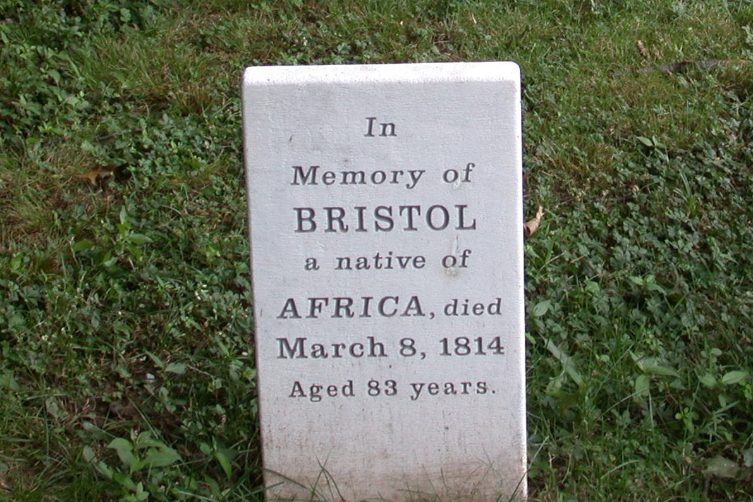

This new gravestone was added to the Old Burial Ground in 2004 when the original (now at Bristow Middle School) broke off at the ground level. His name was spelled variously as Bristow, Bristol, Bristoll and Bristo. This site, in the northwest corner of the cemetery, is a part of Connecticut’s African American Freedom Trail. Source: Noah Webster House & West Hartford Historical Society.

Imagine Bristow’s decision. Terry Schmitt, Board of Education member, suggested that Bristow was a man who could bridge cultures and that was why Schmitt said he voted to name the new middle school after him.

Bristow was an African-American who, after buying his freedom, continued to respect and be respected by the children of his master. That could only have happened if this was a two-way relationship from a man who knew what it meant to be free and be human.

## Putting the Pieces of an African-American Life Together

*Originally appeared in West Hartford Life, February 2006*

The Noah Webster House’s newest exhibit, “Bristow: Putting the Pieces of an African-American Life Together,” opens February 28. The exhibit is the culmination of a year’s worth of research, collecting artifacts and puzzling out the mysteries of Bristow.

Come visit, read, see, and feel Bristow’s experiences in the context of an 18th century home.

Noah Webster House Executive Director Chris Dobbs, explains that one of the challenges for public historians is to catch the emotions of their audience. He argues that reading about the past and seeing pictures can pique curiosity, and once the emotions are stirred, people’s memory is enhanced.

Mr. Dobbs wants this exhibit to be a visceral experience that draws visitors to the house.

You can sit on a bench and see images of a British slave ship carrying African captives. You’ll be below deck with a hatch above you. You can hold the shackles for the below-deck scene of the middle passage.

A blacksmith from Mystic Seaport reproduced the type of shackles that would have been found aboard a ship in the mid-1700s. These shackles linked the captive to the person on either side through a horseshoe and rod, and were chained to a place on board the ship with a lock holding the individuals together. Captives were riveted together and only a blacksmith could undo them. Even feeling the weight of the shackles gives some sense of the agony of the middle passage.

Some time after Bristow arrived in the West Division of Hartford, he was acquired by Thomas and Sarah Whitman Hooker. Sarah was the daughter of John Whitman, a slave holder. Might Whitman have given Bristow as a gift to the newly married couple in 1769? We don’t know the answer. We do know that at age 43, in 1775, Bristow bought his freedom for 60 pounds as Thomas Hart Hooker made his way to Massachusetts to fight in the American Revolution.

Imagine an enslaved man earning what was the equivalent of $9,500 today, working in his spare time on farms beyond that of the Hooker’s. In the exhibit, you can view a copy of Bristow’s manumission papers from the Connecticut Historical Society.

Those who visit the exhibit will be able to fill out a copy of a manumission paper to document their own freedom. Imagine the value of that paper for free African-Americans who lived in a tenuous state of semi-freedom in New England.

An interactive flip panel will help participants understand the limitations of freedom for those freed by the gradual emancipation law in 1784 or by buying their freedom.

Unlike most African-Americans in the late 18th century, Bristow had economic success. He bought three acres of land and a grist mill in 1788 in Bristol. The exhibit will display a copy of the land deed. He bought these properties for “the consideration of 140 pounds lawful money,” more than double the cost of his freedom. Bristow sold the land for 85 pounds four years later, at a substantial loss. A map in the exhibit shows where the grist mills in Bristol were in the 1790s.

While Bristow owned the land he wrote a will, something unusual for an African-Americans in the 18th century. He bequeathed his property to his former owner Sarah Whitman Hooker’s children; they were 21 and 17 at the time the will was written.

By the time Bristow died in 1814, his estate was worth $600. You can see a copy of his real will, which is held at the Connecticut State Library.

These historical documents will be set against three original pieces of art by Brian Colbath, an accomplished West Hartford artist. One painting is a collage of the major events in Bristow’s life. The painting will be in the exhibit, scanned and printed onto magnets, so that those who visit the exhibit can piece together Bristow’s life on a magnet board.

The second work is a five-by-six-foot painting of the Sarah Whitman Hooker House, which will be the backdrop for Bristow’s and the West Division’s main economic activity, farming. A real wood and iron plow from the 1790s will be displayed here. In the late 1800s, in a memoir of early West Hartford, Bristow was hailed for his agricultural expertise.

The third mural is of a liberty tree, an elm planted at the Sarah Whitman Hooker House. Elm trees were planted as liberty trees in the 1770s as a symbol of the American Revolution; the first elm named a liberty tree was in Boston, where an effigy of Massachusetts Gov. Thomas Hutchinson was hung in reaction to his enforcement of the Stamp Act.

All along the street in Elmwood, citizens planted elms which gave that section of town its name. There is evidence that either Amboy or Bristow planted the elm at Sarah Whitman Hooker’s House. Those who view the exhibit can imagine the strength and symbolism of these trees.

The exhibit is part of a series of events during February and March 2006 that will highlight the role of African-Americans during Bristow’s lifetime. On February 12, West Hartford native Jenifer Frank will discuss her book, *Complicity*. On March 9, this author will lead participants through a series of primary documents that tell the story of African-Americans in the 18th century West Division.

The exhibit will remain at the Noah Webster House for about six months and then will travel to Bristow Middle School as a permanent exhibit.

History museums are one of the prime ways that Americans learn history. Museum exhibits often provide a way into the past not offered by books or television or the big screen. Be part of the growing number of Americans who learn and feel history at museums. Check out the Noah Webster House exhibit, beginning February 28.

## Rochambeau and the Revolutionary West Division

*Originally appeared in West Hartford Life, June 2005*

The West Division was a vibrant farming community when le Comte de Rochambeau and his French army of about 5,000 men marched through in 1782. In May 2007, West Hartford commemorated his march by installing a marker at the Sarah Whitman Hooker House. This marker shows us how a war had far reaching effects on the homefront in our town.

The Revolutionary War was over when Rochambeau marched through, but the effects of the seven-year war reverberated through the town’s economic and political life.

Nathan Perkins was a young pastor in 1775 when he gave an impassioned sermon in which he delivered a scathing attack on British imperial policy as a threat to the New England way of life. He delivered his speech in a patriot hotbed. Most locals had voted to support non-importation of British goods and once the first shots were fired at Lexington, West Division men volunteered to fight.

Out of a total of about 1,000 people in the West Division during the American Revolution, about 250 would have been adult males. Twenty-six men died, about 10% of the adult male population. These men had an average age of 33. Thomas Hart Hooker was the first West Division man to die in December 1775 after fighting in Boston. In 1778, members of the militia went to Ticonderoga and a Negro servant of John Whitman Jr., named Pent, died in the camp. The widows and families of those who died were forced to rely on each other to survive.

The first turning point in the war came in 1777 at the Battle of Saratoga. British General John Burgoyne invaded upstate New York from Canada hoping to meet up with William Howe’s troops in New York to cut New England off from the other colonies. Burgoyne captured Ticonderoga. In October, Burgoyne surrendered to American troops at Saratoga. Howe’s troops never made it north. This was a big blow to the British and proved to be more than a military victory for the Americans.

This victory led to the French making an alliance with the United States and sending about 6,000 troops to the United States to help in the war effort. Jean Baptiste Donatien de Vimeur, le Comte de Rochambeau, led this group from France in 1780. When they landed in Rhode Island in July, they were quickly put to work. Rochambeau marched to Connecticut in May 1781 where he met with Washington in Wethersfield. His last visit in 1782 was the one commemorated in May 2007.

In the West Division, citizens celebrated Burgoyne’s defeat and Ebeneezer Faxon organized the planting of elm saplings at the corner of Quaker Lane and New Britain Avenue (then South Road). The elm was a symbol of liberty in colonial New England. Patriots in Boston hung tax collectors in effigy from the elm Liberty Tree in Boston.

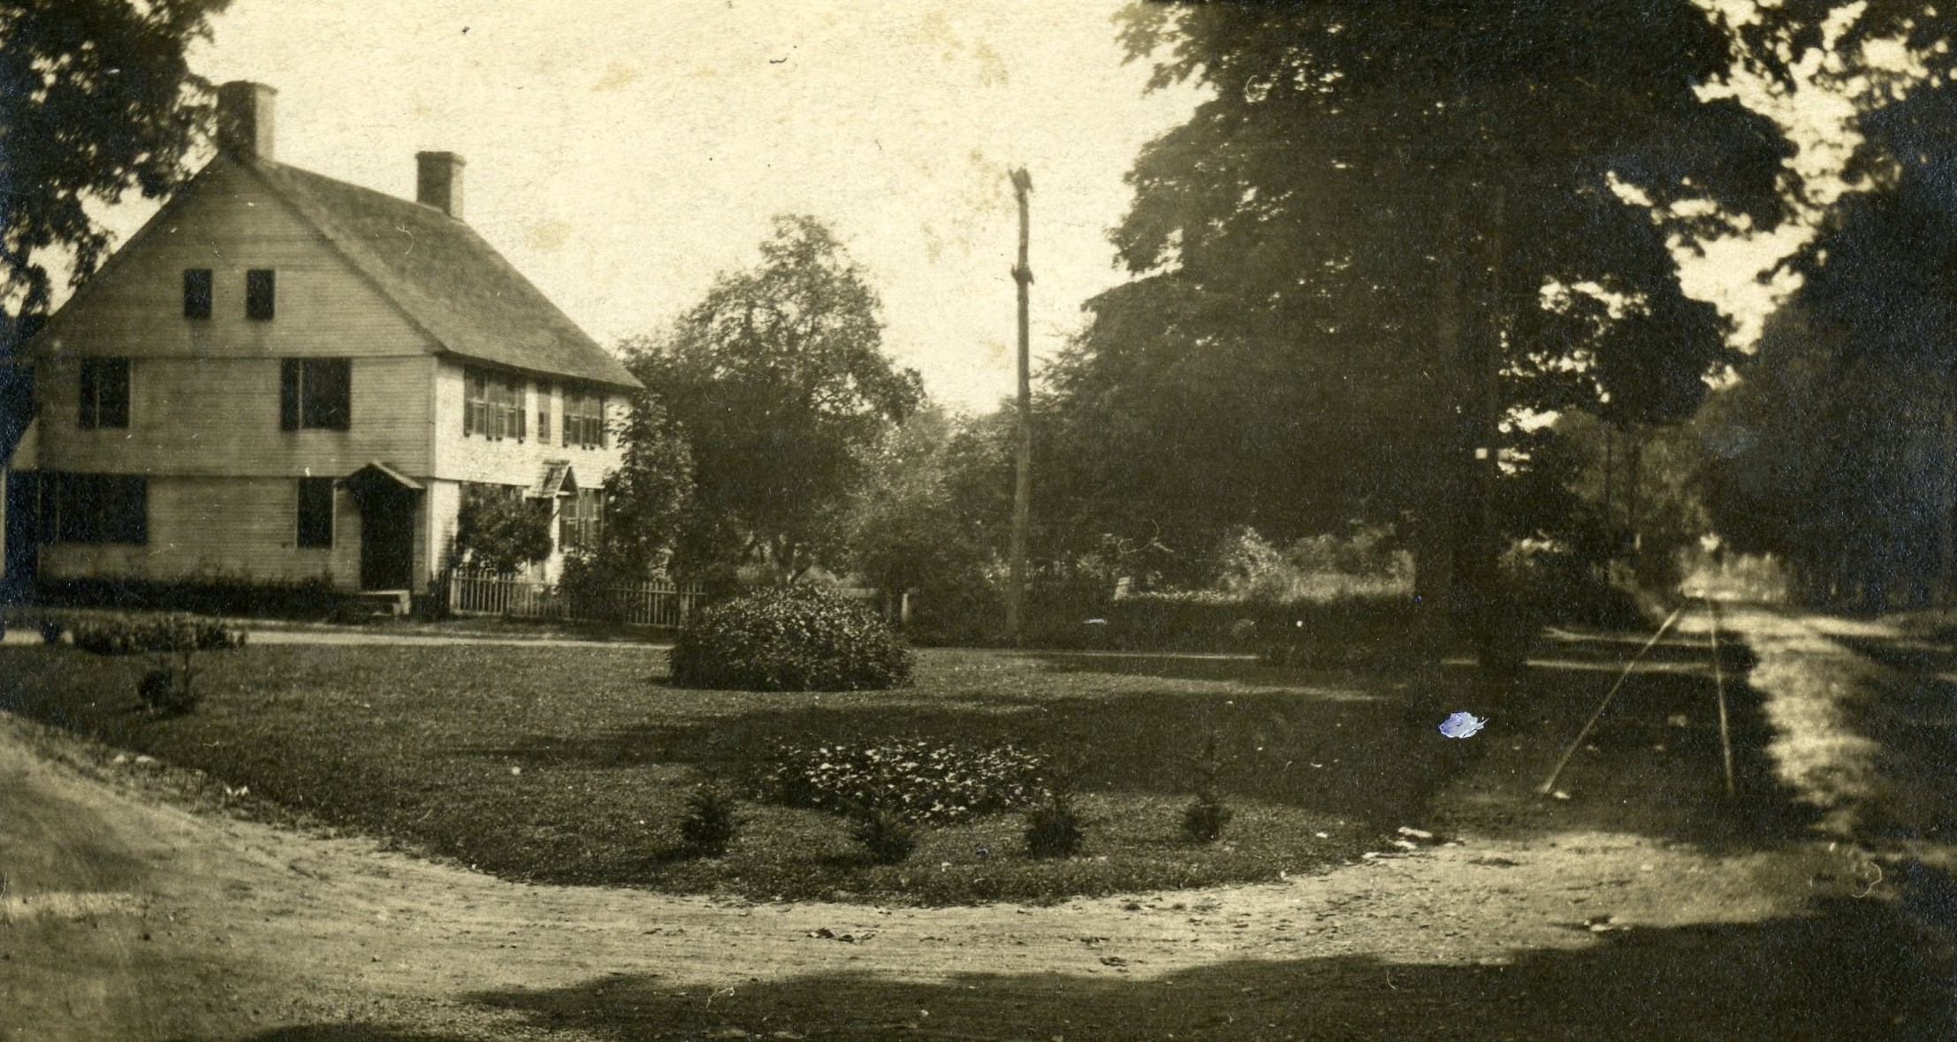

Ebeneezer Faxon, a potter, celebrated the win over General Burgoyne in 1777 by planting elm trees on his front lawn and along what became New Britain Avenue. After the elms died in the 1940s and 1950s, the Elmwood community has funded the replanting of elms in Victory over Burgoyne Park, also known as Blanchfield Park. Source: Noah Webster House & West Hartford Historical Society.

The town also participated in the war effort by providing land for a Revolutionary War Camp set up on Albany Avenue as early as 1776. Some of the original fireplaces remain. When soldiers stayed at the Revolutionary War Camp in 1779, townspeople benefited by supplying them with provisions. At least 50 West Hartford men supplied goods and services including coffins, medicine, milk, Indian meal, straw, wood, hay, horses to use to transport sick from Hartford to the West Division, Indian corn, turnips, mutton, vinegar, oats, horse feed, paper, and transportation.

According to West Hartford’s first Town Historian Nelson Burr, West Hartford sheep supplied wool for blankets, which the people sold to army quartermasters at the campsite on Albany Avenue up Talcott Mountain. The potter, Ebenezer Faxon, supplied tow cloth, a mixture of wool and linen. The army bought cows for food for the soldiers.

Aside from supplying the encampment, West Division families made money by supplying soldiers in the war. In 1777, 21 families provided blankets for the militia. Thirteen more families supplied beef cattle to the army between 1775 and 1777.

Moses Goodman & Co. ran a distillery one mile west of the West Hartford meeting house, probably not too far from present day Gin Still Lane. Moses was the son of Timothy Goodman who lived on Mountain Road. These distilled spirits were a boon to the men who marched through and those in camp.

Even those not directly involved in provisioning the army were affected by the war. People had to sacrifice in their businesses for the war effort. In 1779, Ebenezer Faxon asked the General Assembly to let him purchase lead in Boston for his pottery business in exchange for three barrels of flour and a hogshead of Indian corn. He declared that his occupation was necessary for the town, but the General Assembly turned him down, deeming lead for the war effort more important than for his pottery.

Governor Trumbull asked the West Division to house British and Loyalist prisoners from the battle at Fort Ticonderoga. The British prisoner of war Colonel Philip Skene was moved from Middletown to West Hartford when his African slave John Anderson, attempted to become Negro Governor of Connecticut. Connecticut officials believed that the British, through Skene’s slave, might encourage the Connecticut slaves to revolt against their masters, thus helping the British cause. Sarah Whitman Hooker House housed Skene on the corner of New Britain Avenue and South Main Street from July 26, 1775 until September 1776. It is probable that Hooker’s house had a tavern. Its previous owners, Timothy Seymour, held a license for a tavern starting in 1733. It is likely that Hooker’s house was a meeting place for political talk about the war as well as a place to rest, eat and drink.

Though the fighting was far from the West Division, we were about halfway between New York and Boston and many armies marched through, along the street where the liberty elms were planted. What is now New Britain Avenue, but used to be called South Road, was an important military highway, according to Burr.

Another French soldier, Marquis de Chastellux, who marched through in 1780 wrote in his journal that he noticed the “inhabitants engage in some industry in addition to their prosperous agriculture, some cloths and other woolen stuffs are manufactured here.” He went in a house in which they were weaving and dyeing cloth.

It wasn’t until October 1782, a year after the British surrender at Yorktown, that Rochambeau marched back through the West Division with his men from Yorktown to Boston. It is thought that he may have stopped at Sarah Whitman Hooker’s house. By that time, her husband Thomas Hooker had died in the war, and she had remarried Seth Collins in 1779. Her children were 13 and 11. Though her slave Bristow had bought his freedom in 1775, Hooker still held Amboy as a slave.

Sarah Whitman Hooker’s life during the revolution shows probably as much dislocation as any in the town. In 1775, Bristow bought his freedom from she and her husband. Her husband went off to war and died leaving her with a 6 and 4 year old. She ran a tavern during the war and held prisoners of war there. The French army marched by her house and probably stopped for provisions. But like many Americans, she was able to adjust, take advantage of her circumstances, and endure the political and economic turmoil. She remarried in 1779 and readjusted her life. Using her as an example, it is clear that social, economic and political life in this small town changed as dramatically as it ever did in a short period of time.

## Bring on the Elms

*Originally appeared in West Hartford Life, November 2007*

On October 6, the Elmwood Business Association and the town planted a disease-resistant elm, with 12 more to follow, on the Elmwood green in the former parking lot of Talcott Junior High School. This tree planting has its seed back when the first elms were planted in 1777, giving this section of town its name.

Symbols are significant to every community. For Elmwood and West Hartford, the recent planting of the elm symbolizes a love for liberty defined during the Revolutionary War, reconciliation with opponents and it reinforces the sense of community which Elmwood has had since the original elms were planted.

First and foremost, the elm tree stands for liberty, harking back to its significant role in the Revolutionary War. The elm was a liberty tree, first getting its fame in Boston in 1765 as a symbol of resistance to tyranny. Tax collectors were hung in effigy from the Boston elm.

In Connecticut, the oak tree from the Charter Oak story served as the symbol of liberty more often than the elm. But the important piece here is that Ebeneezer Faxon had to plant the trees; as you may know, there are oak trees everywhere in West Hartford. The elm was a special tree and Faxon’s action was noticed and helped bring an identity to the community.

The specific trees planted in Elmwood hearken back to the Revolutionary War, commemorating the Patriot win at Saratoga over British Gen. John Burgoyne. This was no small battle. The British were 9,000 strong at this battle and they surrendered on October 6, exactly 230 years before the replanting.

This battle secured the northern American states from further attacks out of Canada and prevented New England from being isolated from the rest of the colonies. Burgoyne’s force was made of 3,000 red-coated British, 3,900 German mercenaries and about 650 Canadians, Tories and Indians from Canada. This multinational force surrendered to a larger Patriot force under General Gates.

But the treatment of the enemy seems unusual to us today. The demand for unconditional surrender was flatly turned down by Burgoyne, but eventually a treaty of convention was accepted as the British agreed to not surrender, but be taken as prisoners of war and be marched to Boston and returned to England on condition that they would not serve again in the war.

On October 17, 1777, Burgoyne appeared before General Gates in his full ceremonial uniform and they greeted him with formal cordiality. About 6,000 men were surrendered to the Patriots. This common 18th century military practice, however, was not carried out.

The Continental Congress refused to ratify the convention and the enlisted men were held in captive camps in New England, Virginia and Pennsylvania until the end of the war. It seems that Charles I, Duke of Brunswick, did not want the soldiers back in England. He believed their presence would hurt recruitment for the duration of the war. Many of the British soldiers were housed by local patriots and ended up becoming Americans.

Burgoyne and Gates, as the story goes, had a cordial dinner party after the battle, with Burgoyne toasting George Washington and Gates replying with King George III.

Frederica de Riedesel, the wife of a German mercenary and the daughter of the Prussian minister of state, was 31 when she witnessed the dinner party in the fall of 1777. She wrote a journal, published in 1801, in which she recorded the events:

We reached Albany, where we had so often wished ourselves; but did not enter that city, as we had hoped, with a victorious army. Our reception, however, from General Schuyler, and his wife and daughters, was not like the reception of enemies, but of the most intimate friends.

They loaded us with kindness and they behaved in the same manner towards General Burgoyne, though he had without any necessity ordered their splendid establishment to be burnt All their actions proved that at the sight of the misfortunes of others, they quickly forgot their own.

Burgoyne was so much affected by this generous deportment, that he said to Schuyler you are too kind to me who have done you so much injury. Such is the fate of war, he replied; let us not dwell on this subject. We remained three days with that excellent family and they seemed to regret our departure.

This scene, describing the reconciling of enemies, reminds us of the importance of the results of battle. How are we to live together when the war is over if we objectify the enemy? This treatment of prisoners of war was not unusual during the Revolution.

In the West Division of Hartford, Sarah Whitman Hooker held prisoner of war Philip Skene during the war. On July 26, 1775, Ethan Allen sent him and his slave to Hartford after the capture of Fort Ticonderoga. It seems Hooker also held dinner parties in her home for the prisoner of war. Coming face to face with the opposition humanized the enemy right here, as it did in Albany.

It is thought that Hooker’s freed man Bristow planted an elm on the front lawn of their New Britain Avenue home. The Burgoyne elms helped to establish a sense of community in the southeastern section of town. They were planted in the West Division while Skene was held as prisoner of war. The elms helped to define a part of Hartford separate from the West Division, leading to the name Elmwood.

This sense of community and love of liberty remain today.

But the lesson of reconciling with our enemy takes even more strength to develop and is a more difficult lesson to practice.

## Elmwood’s Elm Trees Stand as a Powerful Symbol of Liberty

*Originally appeared in West Hartford Life, November 2008*

The Elmwood section of West Hartford has had a long tradition of planting elms. On October 4, Duffy Cub Scout Pack 161 planted a Liberty Elm at Burgoyne Park as part of Elmwood’s project to “reclaim Elmwood.”

The planting of this elm represents a positive good for the environment, a community activity and a way to connect with a past that defined and redefined liberty.

In New England, elm trees are a symbol of individual liberty and of resistance to tyranny. In 1777 the first elms were planted and when this section of town got the name Elmwood, the area was still part of the city of Hartford. In Connecticut, because of the Charter Oak incident, many think of the oak as the tree of liberty, but in Elmwood, the idea of the liberty elm endures.

In mid-October 1777, American troops defeated British General Johnny Burgoyne at Saratoga, New York, at what scholars call a turning point in the American Revolution. To celebrate, Capt. Ebenezer Faxon and his friends planted a small grove of 13 elms, one for each colony, at New Britain Avenue (then called South Street) and South Quaker Lane (then called East Street) as a lasting monument to Burgoyne’s defeat.

Faxon was the founder of the Elmwood pottery and his homestead was on the northeast corner of the intersection. As the elm saplings grew, they became a town landmark known as the Burgoyne Elms.

The history of the elm as a liberty tree began in 1765 as a protest against the British-imposed Stamp Act. That protest showed support for individual liberty and resistance to tyranny. The story of the first liberty tree, an elm tree, began in Boston on August 14, 1765. As farmers streamed into Boston for market day, they walked along a line of elm trees in front of Deacon Jacob Elliot’s house. As they looked up, they saw a body hanging from a branch. It was an effigy marked with the initials A.O. – Andrew Oliver. He was a Boston merchant who had agreed to collect the new Stamp Tax levied on the colonies.

During that summer day, the size of the crowd around the tree grew. Public officials felt they needed to control the crowd. The sheriff ordered the effigy to be chopped down, but his deputies said they would be in danger of their lives if they did so. The effigy was hung by a Boston group called the Loyal Nine, men who were avowed Whigs who detested tyranny. The Nine were men of property and standing who became the core of the Sons of Liberty.

When the Nine discussed their protest the previous night, they knew economic times were not good. The colonies were caught in a world depression. The British Parliament imposed a new stamp tax without their consent and they believed they could not afford it. Every member of the Loyal Nine was directly threatened by the tax. The printer had to put a tax on every issue of a newspaper and on advertisements; artisans and merchants had to pay taxes on each contract, indenture, and bill of sale. Distillers and attorneys had to pay a tax on licenses, and citizens had to pay taxes on school diplomas and militia commissions.

Clearly the British Parliament believed the American colonies had too many newspapers, schools, attorneys, and liberties. To the Loyal Nine, the elm tree symbolized access to information, access to an education, rule by law, and individual liberty.

In the early 1800s, it is thought that Bristow, the African man who was owned by the Hooker family, planted a Liberty elm on the lawn of the house the Hookers owned. A photograph from the late 1800s shows the mature tree with a caption saying that the tree was planted by a slave of the Hookers.

I wonder if Bristow planted that tree before or after he bought his freedom.

By the late 1800s, the traffic on Quaker Lane increased. I think that a line of elms served as a median strip for the two lanes of traffic. People used the road to get to the Beach creamery north of New Britain Avenue.

In 1926, more elms were added to Elmwood when the state Highway Department awarded a contract to plant 85 American elms along New Britain Avenue from Hartford through Elmwood to New Britain. Many elms were killed in the 1940s and 1950s by Dutch Elm Disease, but that was not the only way that Elmwood lost its elms.

In 1957, with the opening of Elmwood Plaza, Quaker Lane had to be widened again and 22 elms that formed the island known as Victory over Burgoyne Green were chopped down and replaced with a triangular green made of asphalt with a flagpole.

In 1957, the spirit of progress overtook the ideals of liberty. A Hartford Courant reporter wrote, “the passing of Burgoyne Green is just another price that must be paid for progress. Along with the green went 22 large trees along the avenue that had been the pride of the Elmwood community for hundreds of years.”

By re-elming Elmwood, today’s citizens make a connection with the past that symbolizes a belief in access to information, education, rule by law and individual liberty, all ideals shared by the West Hartford community.

Drive by Burgoyne Park and take a look at the two elms planted there. These trees will grow just like the stately elms that lined New Britain Avenue.

The enlarged park abuts the new Quaker Green condominiums and provides more space that the previous park bench and flag pole that were squeezed onto the corner. Now, a former asphalt parking lot has been greened and “elmed.”

*Note: On October 30, 1996, the town officially renamed Burgoyne Park as William E. Blanchfield Park in honor of the late longtime local resident and businessman. He owned the Battey Shoe Store in Elmwood for many years and raised and lowered the park’s flag every day. He volunteered extensively in youth sports and is a member of the West Hartford All Sports Council Hall of Fame.*

## Researching the Revolutionary War Dead

*Originally appeared in West Hartford Life, April 2005*

The voluminous work of the Veteran Memorial’s Joe Donahue, researching every veteran who died in uniform from West Hartford, compels me to try and make meaning out of the facts of their service, the tragedy of their deaths, and the sacrifice of their lives for the larger cause. The local connection makes the American Revolution come alive.

Twenty-six men from the West Division died in uniform in the Revolutionary War. Three quarters of the West Division’s men died by the end of 1776, just six months into the war. Their average age was 33. Their median age was 31. Two men died at age 50 and one man died at age 17.

Of the 26 men, there is a record of service for 21. Cornelius Flower served just five months before dying in camp of putrid fever. Epaphras Bull served for 56 months before he died of fever in Williamsburg, VA in September 1781, about 2 weeks before the British surrender at Yorktown. The average time of service was 17 months

Eleven men died “in camp.” Seven died of fever Two of the 26 died in battle: Aaron Henery died of a wound at Fort Anne, NY, and Eli Mix died in an assault at Stony Point, New York. Three men, Jonathan Gillet, Joel Clark, and Joseph Mygat died after being released from prison ships.

As soon as news of the Battle of Lexington April 19, 1775 made it to the West Division, men answered the call. Thomas Hart Hooker enlisted into Connecticut’s Second Regiment under the leadership of Captain Samuel Wyllys of Hartford on May 10, 1775, just 25 days after the Battle at Lexington in what was known as the “first call” for troops from the state legislature. Hooker served at the siege of Boston and died of peripneumonia at the age of 30. On November 26, 1775 he became the first West Division man to die in the war. Just before he left for the war, Bristow bought his freedom from Hooker for 60 pounds. Hooker’s genealogy claimed Hooker gave Bristow his liberty before going to “fight for liberty” from the British.

West Division men fought in the next battle at Fort Ticonderoga. New York and three died there. Controlling Boston depended on an attack of this Fort about 150 miles away from Boston. The Green Mountain Boys, led by Benedict Arnold and Ethan Allen, surprised the British garrison and then hauled the fort’s heavy guns to Boston. The threat of bombardment forced the British to evacuate Boston.

The West Division men thought, like most of the Patriots, that they were involved in a skirmish, not a Revolution. The Patriot Army left a list of artillery taken from Fort Ti. They thought they would return the arms to the British as soon as things calmed down. The British remained uncertain about whether or not they were actually engaged in war. They believed they were only quieting pockets of rebellion.

West Division soldiers John Cowle, Cornelius Flowers and John Steele all died at Ticonderoga between April and October 1776. Members of their militia held onto Fort Ticonderoga to stage an assault on British Canada. Arnold threatened Quebec after a difficult winter march. The Patriots were frustrated in Canada when they could not get the Canadians to ally as a 14th state. Cowle was 50 years old when he died in the camp. He enlisted in August 1775 and died six months later. Cornelius Flowers also died at age 50 in the camp of “putrid fever.” John Steele was an army private who died of “putrid fever” as well was 17 and had served 18 months. His regiment helped Gen. Schuyler reinforce the troops besieging Quebec. They retreated in April 1776 and were stationed in Ticonderoga. The men suffered severely from smallpox. The assault on British Canada was not successful, but the British evacuated Boston and many Loyalists fled to Halifax.

Nineteen of the West Division’s 26 men died in the second phase of the war in the Mid-Atlantic region. Fourteen died in 1776 and 12 of them at the outpost of Peekskill on the Hudson, north of New York City. Most of them are listed as dying “in ye camp.” Two died of “putrid fever.”

The British regrouped in the waters around New York City under Sir William Howe. He had 32,000 trained soldiers. Washington had 19,000 men who were poorly armed and poorly trained. Washington had no navy. Still, the Continentals fought and suffered one defeat after another as the British pushed them out of Manhattan, over the plains of New Jersey, across the Delaware River into Pennsylvania. Two West Division men, Lt. Col. Joel Clark and Private Joseph Mygat died on a prison ship in the waters around New York in 1776.

The British hunkered down for the winter of 1776-7, but George Washington recrossed the Delaware River on Christmas Eve. Joseph Hulbert from the West Division was with Washington when he crossed the Delaware. Hulbert died that night. He had served for 20 months in the war. Washington’s troops scattered the Hessian soldiers and claimed two minor victories at Trenton and Princeton.

In 1777, Horatio Gates defeated Burgoyne at Saratoga, New York. The citizens in the West Division were so excited that, led by Ebeneezer Faxon, they planted a living memorial in a park named Victory over Burgoyne at the northwest corner of Quaker Lane and New Britain Avenue.

At the same time, Howe headed for Philadelphia taking many of his troops with him to take the Patriot capital. In Washington’s unsuccessful attack on the British at Germantown, Pennsylvania, 17 year old Lewis Stanley was killed after serving for 2 years and one month in the militia as a Minuteman. Stanley must have been 15 when he signed the second call. He died “in captivity.” He served under Col. Jebidiah Huntington at Germantown.

When George Washington retreated to Valley Forge, February 16, 1778, William Wheeler, an army private was with him. Wheeler died with many others at Valley Forge where soldiers suffered from sickness, cold and starvation.

Jonathan Gillett died at home after being held prisoner by German troops in British service for 18 months. The Hessians confined him on a prison ship in New York Harbor. He was disarmed, and beaten. The prison ships in New York harbor were notorious for filth, disease, and cruelty. One of Gillet’s letters to his wife Elizabeth detailed his being disarmed, beaten by the Hessian soldier’s gun butts and treated unkindly. He was released after 18 months and returned to the West Division but died in December 1779 at age 41. He and his family lived in the house just north of the Noah Webster House on the east side of Main Street.

Epaphras Bull, aged 33 and a Major in the Army died of fever after serving for four and a half years in Williamsburg Virginia, just two weeks before Cornwallis’ surrender at Yorktown.

About 5,000 Patriot men died in the Revolutionary War, only a fraction of the 58,000 in the Vietnam War. Out of a total population of about 1,000 people in the West Division, 26 men died – approximately 5 percent of the male population of the town. These men, whose average age was 33, left widows and families. Those on the home front sacrificed by not importing British goods. The dislocation of this war, in retrospect, loomed large. In the Vietnam War, 18 West Hartford men died out of a population of about 70,000, or 0.05 percent of the male population.

But both wars split the community as its citizens debated the merits of fighting for democracy and independence. Joe Donahue’s statistics of those who died in uniform bring home the heroism, tragedy, and misery of war.

## Naming the New Middle School: Bristow or Sperry?

*Originally appeared in West Hartford Life, August 2004*

As a high school history teacher, I am constantly considering what to include and what not to include in the curriculum. How much should I focus on leaders who made decisions which affected large numbers of people and changed the way people acted and thought? How much should students learn about those who left little record but were instrumental in building our nation?

It is this choice, it seems, that the Board of Education is faced with in naming the new middle school on Highland Street to open in September 2005. What the Board decides will be a symbol for the community.

A committee has narrowed the choice to two names: Bristow (1728-1811) and Roger W. Sperry (1913-1984). This is the choice of two men, the first who spent almost his entire life in West Hartford, and the second who spent his formative years here. This is the choice of an enslaved and then free African man and a white well-educated man. This is the choice between one man who had to fight for his very survival and another already well-recognized for his accomplishments. Each man is worthy of having a school named after him, but on the face of it, Sperry certainly has the credentials.

Sperry’s brain research had a great impact on further research in psychology and medicine in the 20th century. In his lifetime, Sperry published 290 scientific articles.

He discovered that the neural network that connects the sense organs and muscles to the brain is hardwired. He disproved the theory of his mentor, Paul Weiss at the University of Chicago where he got his PhD in 1941, who believed that the neural network was randomly connected. Sperry’s experiments, which included surgery on fish, salamanders, and monkeys, showed that the development of this neural network is just the opposite of what Weiss believed. In fact, each nerve cell, he found, was tagged in the embryo with its own chemical individuality and the function of the cell was fixed for life.

Sperry did not win the Nobel Prize for this discovery. He won that prize for his discovery on split brains. Sperry determined that both hemispheres of the brain are conscious and can act separately. This finding came again, from Sperry questioning the accepted theory that sectioning the corpus callosum, the large band of fibers that connects the two hemispheres of the brain, did not affect behavior. Sperry investigated first with cats and monkeys, and then later on humans whose brain hemispheres were surgically separated to control epilepsy. Sperry found that the right hemisphere was conscious, and could perceive, think, remember, reason, and emote. Further, he argued, the right and left hemispheres could be conscious, carrying on mutually conflicting mental experiences at the same time.

Sperry was born in Hartford to Francis Bushnell, a banker and Florence Kraener Sperry. His mother was born in Elmwood. Sperry’s father died when he was 11 and Roger took his mother’s surname. When his father died, the family moved to West Hartford, and his mother became the assistant to Hall’s principal for almost 20 years starting in 1924.

Sperry went to elementary school in Elmwood possibly at Charter Oak School. In his autobiography, found on his [website](https://web.archive.org/web/20041216090652if_/http://www.rogersperry.info:80/), Sperry wrote that he “collected and raised large American moths in grade school.” When he was at Talcott Junior High, he “ran trap line and collected live wild pets.”

At Hall High School, from which he graduated in 1931, Sperry was not just an academic. He was also an accomplished athlete who lettered in football, basketball, baseball, and track. At Oberlin College, Sperry was the captain of the basketball team and also lettered in football, baseball and track.

As an adult, Sperry practiced what his Hall yearbook quote proclaimed, “There’s time for work and time for play.” In 1981, at the time the Nobel Prizes were being awarded, Sperry left Caltech for a week’s fishing vacation with his wife. It was over a week before he came back and actually knew he’d won the Prize. In his spare time he was an artist in sculpting, ceramics, water colors and figure drawing. He loved American folk dancing, fishing, boating, and snorkeling. And he had a large collection of unusual fossils.

Clearly, Sperry has much to offer as an inspiration to school children and townspeople.

Bristow may, too, have been a renaissance man, but the documentation on him is not nearly as rich. Bristow is the only African American with a marked headstone in the Old Burial Ground on North Main Street in West Hartford. Bristow spent about half of his 83 years as an enslaved person. He was born in Africa and was involuntarily brought to the America when it was still a colony. He was owned by Thomas Hart and Sarah Whitman Hooker until 1775 when he bought his freedom for 60 British pounds. The fact that Bristow could raise 60 pounds shows the ability of enslaved people to make money and Bristow’s initiative to better his position in society. According to the recently published *Celebrate! West Hartford*, Bristow became an agricultural expert in his later years and farmers in town consulted with him.

Booker DeVaughan, the President of the West Hartford African American Social and Cultural Organization, was the impetus behind Bristow’s new headstone in the Old Burial Ground and in getting this headstone placed on Connecticut’s Freedom Trail. DeVaughan, in his dedication of the headstone on June 12, argued that Bristow represented many attributes that make him the quintessential American. He represents those ever-present American traditions of self-improvement, upward mobility, and reinventing ourselves.

We have only three pieces of primary evidence about him: his gravestone, his manumission papers, and his last will and testament. Much of what we make of Bristow comes from the ideas of social historians who study those who have not left a record and try to place them in the context of their times.

We don’t know if Bristow was literate, if he had a family, or if he made any important agricultural discoveries. But we can surmise, from information gathered about involuntary African immigrants, that Bristow had no formal schooling. He probably lived in the Hooker homestead at 1237 New Britain Avenue, and probably did a variety of jobs for the Hookers. Unlike slavery in the south, where those enslaved repeated the same tasks over and over, men like Bristow in the north, could learn a trade and could hire themselves out and make money.

Bristow represents the African American presence in the West Division which goes back to 1738. Sally Whipple, former Director of the Noah Webster House, researched African Americans for an exhibit the Noah Webster House in 1989. Her research through land and probate, birth, marriage, death records and account books shows how much African Americans were an integral part of the town in the 18th and 19th centuries. The first record of an enslaved African American is Jack, born in 1696 and owned by Col. Whiting.

Between the years 1738 and 1791, at least 20 white West Division men and women owned at least 37 black slaves. If there were 124 families in town in 1764, over 15% of the families owned Africans. These families were those that were wealthy and leaders of the town. Two of the first three ministers, Benjamin Colton (1713-1759) and Nathan Perkins (1772-1838) owned Africans. When Colton died in 1759, his inventory listed a “Negro” worth 33 pounds. This “negro” was probably Chris who had been baptized in 1758. By law, at Colton’s death, Chris was passed on to his son Abijah Colton.

John Whitman grew up in a house with slaves. To pay for purchases in 1740, Thomas Hosmer paid Whitman’s father “a negro named Ned a boy of nine years old w[orth] 115 [pounds]. Enslaved people were split from families, and even those who were free, lived in quasi-freedom.

In Dr. DeVaughan’s dedication of Bristow’s headstone, he said that “with all his American traits, however, he very well may not have risen to the very pinnacle of success. He was marginalized because of who he was . . . freedom for Bristol and his contemporaries was severely limited.”

Students in my Local History class leaned toward naming the school after Bristow. “We stand for diversity in this town,” one student said, and “we shouldn’t just give it lip service.” Another said that Bristow spent all his life in West Hartford and that gave him an edge.

Both these men are exemplary. The more I read about Sperry, the more I think, how could the Board not choose him? Yet there is this part of me that also wants to celebrate the common person, the ordinary citizen who rose above the circumstances to which he was tethered in slavery, the one who represents struggle, freedom and a measure of success beyond what was expected of him. But these attributes could apply to Roger Sperry whose father died when he was young and whose scientific career is characterized by his questioning established theories of giants in his field.

Is the symbol more valuable if the person has reached the pinnacle of society, or is someone who would live among us?

Contact your Board of Education members (Jack Darcy, Beth Bye, Bruce Putterman, Harry Captain, Terry Schmitt, Tom Fiorentino, or Jeanette Becker) with your opinion about the school name.

## Lemuel Haynes Crossed the Color Line

*Originally appeared in West Hartford Life, September 2011*

Who has crossed the color line? Many people in the United States today can lay claim to a family member, neighbor, or friend who has crossed the color line in marriage or in a lasting relationship of some type.

In the mid-1990s Gary Nash, a UCLA history professor, helped to start a movement called Mixed Race Studies in which historians, sociologists and artists focus on understanding multiracial, interracial and transracial adoption populations with a focus on social justice.

Mixed race studies scholars challenge dominant conceptions about race, emphasizing the flexibility of race and the porosity of racial boundaries. They critique how social stratification is often based on race.

West Hartford was the birthplace of Lemuel Haynes (1753 - 1833), a man of mixed race who married a white woman. Haynes’ legacy has been resurrected by the PBS series, *Africans in America* (1998) and by Gary Nash’s book, *Forbidden Love: The Hidden History of Mixed-Race America* (2010).

On July 18, 1753 in the West Division of Hartford, Lemuel Haynes was born to a father of “unmingled African extraction” and Scottish servant girl Alice Fitch. Lemuel took the name of Fitch’s master, John Haynes of West Hartford, likely a descendant of John Haynes, the first governor of the Connecticut Colony who served eight terms and was instrumental in writing the Fundamental Orders of Connecticut.

Haynes took the name of his mother’s master rather than that of his father, implying that his father was enslaved. Lee Ellenwood, former minister at the First Church of Christ, Congregational, suggested that his father may have been Bristow.

Five months after Haynes was born, his mother gave him up to Deacon David Rose of Granville, Massachusetts, who took him in as an indentured servant. Part of the agreement was that Haynes be educated.

Though not much is known of his youth, Haynes spent time helping out on the farm. He attended church and showed a passion for the Bible and books on theology. In his teens, he was exposed to Calvinist thought and conducted services at his local church.

At age 21, Haynes’ indenture expired. He joined the Minutemen of Granville. Haynes marched with his militia company to Roxbury after the Revolutionary War battles of Lexington and Concord. He also volunteered in the expedition to Ticonderoga, NY in 1776 to help protect the fort.

In 1776, Haynes wrote a well-circulated pamphlet entitled “Liberty Further Extended” in which he said “That an African. . . has an undeniable right to his liberty.” Haynes condemned slavery and was one of the earliest to point out the irony of slave owners fighting for their own liberty while denying it to those of African descent.

When he returned to Granville, he was offered a scholarship to Dartmouth College but turned it down and “apprenticed” with local Congregational ministers, learning theology, Greek and Latin, and how to write and deliver sermons.

He spent 1780 in Wintonbury (Bloomfield) studying Greek with the Rev. William Bradford while teaching in the local one-room schoolhouse. He was a Calvinist who read revivalists George Whitfield and Jonathan Edwards from the first Great Awakening. He believed in the absolute sovereignty of God and that human virtue was a reflection of God’s love.

Haynes married Elizabeth Babbitt, who was white, in 1783 in Hartland and stayed married to her for 50 years. They had 10 biracial children born between 1785 and 1804. One of their sons became a physician and another a lawyer.

Haynes was licensed to preach in 1780 and in 1785 was the first African American officially ordained a minister of the Congregational Church. He was first called to be pastor of the Torrington Congregational Church from 1785-1787. He was the first black man in America to serve as a pastor to a white congregation. However, he left after to two years because of the active prejudice of the all-white congregation.

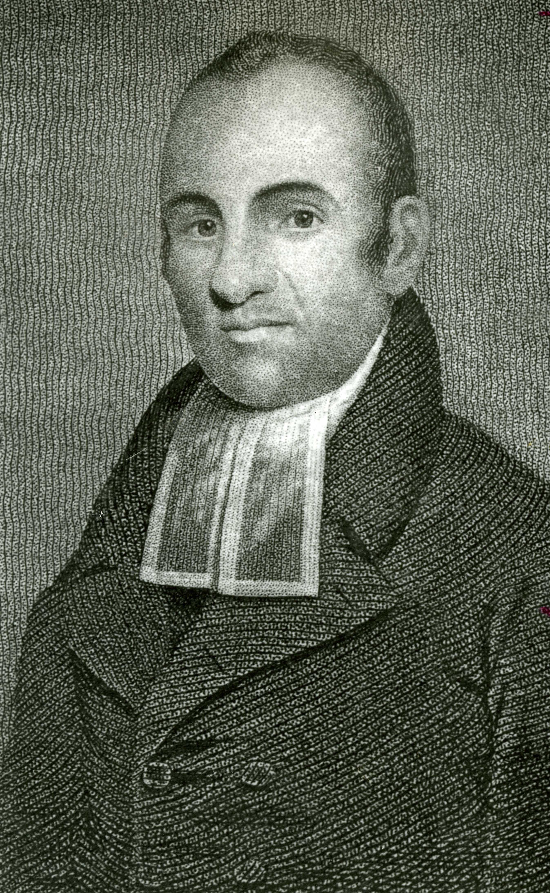

Haynes served as a pastor from 1785 to 1833. He was popular as a preacher and as an intellectual. In his 1776 pamphlet “Liberty Further Extended,” Haynes condemned slavery and was one of the first to point out, in writing, the irony of white men fighting for liberty while enslaving those of African descent. Source: Archives, First Church of Christ Congregational, West Hartford, CT, John P. Webster Library.

Haynes’ longest pastorate was in Rutland, Vt., where he served for 31 years from 1787-1818 until he was 64. While there, his fame as preacher and scholar spread. He earned a transatlantic reputation largely due to his 1804 published sermon against the idea of universalism.

Under Haynes, the church grew from 46 members to more than 300. In 1804 Middlebury College presented him with an honorary degree, the first of his race to win such an award.

But by 1818 he said that conflicts had grown within his congregation that at first seemed to be about politics and style, but in the end seemed to be more based on racism.

He was so popular in Vermont that he preached at a different church every Sunday after his dismissal and then served for three years in a Manchester, Vermont, church. He finally moved to Granville, NY and served his last 11 years as its pastor.

Haynes’ homestead in Granville is now part of the National Historic Register and he and his wife are buried in the cemetery in South Granville, just a mile from his house.

Since his rediscovery in the 20th century, Haynes has been criticized for not coming out strongly enough against slavery. But he needs to be seen in the context of his times. He would have been at the forefront of a moderate approach to the abolition of the slave trade.

According to Gary Nash, he never stopped preaching that “liberty is equally as precious to a black man as to a white one, and bondage equally as intolerable to the one as it is to the other.”

Haynes’ life exemplified the tension between the ideology of freedom in the new republic and that of slavery, as he argued for the full inclusion of African peoples in the new republic.

Haynes crossed the color line yet had to constantly be aware of his color in a country divided by race. His legacy to his birthplace can be to ask if race determines what neighborhoods people live in, if race determines school achievement and if race determines socioeconomic status.

Studying men like Lemuel Haynes can help us to see the social construction of race and help us to think more about whether race overpowers other human attributes which contribute to success. If race does, it makes us wonder even further about those willing to cross that color line.

Why are people like Haynes willing and able to buck societal norms and cross the color line? Who plays Haynes’ role today?

# Noah Webster

# The Market Revolution

# An Independent Town

# A Growing Suburb

# World War I Era

# Development and Reform

# World War II Era

# Post-World War II Era

# Inner Ring Suburb

# The Fight for Justice

# Afterword

**Speech delivered at Ceremony for Dedication of Tracey’s Tree, October 9, 2017**

This speech tells much about my work as Town Historian and the power of history in our lives. Delivered at Burgoyne Park in Elmwood on the occasion of planting an elm tree, now known as Tracey’s Tree. See local news: <http://we-ha.com/traceys-tree-dedicated-honor-west-hartford-historian-retired-teacher-dr-tracey-wilson/>

Good Afternoon!

Thank you so much for this ceremony. I am humbled and honored to have this elm tree planted in my name. Who gets to have something like this?. . .and especially when I can appreciate it. In these days of consciously thinking about who should be commemorated and what statues can stand, I feel even more honored that there was consensus that I’m one for the ages.

First I want to thank Rick Liftig who was the mastermind of this whole thing – and then Jenn DiCola Matos and Pam and Charlie Hilborn who helped carry out the plan. Thanks too, to the Governor’s Foot Guard - which was formed in 1771 and joined the march to the Battle of Saratoga in 1777, for adding to this celebration. And all of you who came - family Beth and Adam and Peter (and Brittany Caroline and Billie who couldn’t be here) and my brother Dave, friends, teacher colleagues, and particularly my retiree partner Liz Devine, former students, the Solidarity Sisters, Katherine who helped me pick the apples yesterday, elected officials and those of you running for elected office and members of the Universalist Church all members of this community for whom I am so grateful to be a part.

Many of you gave money in my name to benefit two of my favorite non-profits – the Noah Webster House and Knox, Inc. - history and gardens are two of my favorite things! Thank you.

To me, the planting of this elm tree represents

* a symbol in history,
* a community event, and
* a tool for educating us about liberty in a democracy.

You see, trees have special significance

* in our environment and also
* as symbols – Marcus Garvey, the great black nationalist, proclaimed 100 years ago,

A people without the knowledge of their past history, origin, and culture, is like a tree without roots.

He knew the power that history can have in people’s lives - that knowing our history cannot only keep us rooted, but history can also give us a firm footing to branch out - to give shade, to reach the sky. And as we are seeing in Puerto Rico, even as soon as a week after the hurricane, those trees whose roots held, already have leaves sprouting.

Our celebration today is about history and it coincides with the day 240 years ago in Saratoga, when American General Benedict Arnold’s troops repulsed British General Johnny Burgoyne’s troops in the Second Battle at Saratoga. This battle turned out to be a turning point in the Revolutionary War. Ten days later, General Burgoyne surrendered 5,000 British and Hessian troops to American General Horatio Gates.

This battle reverberated in France, when the French told American envoy Benjamin Franklin that they would become an ally to the Americans in their fight for independence against the British.

When word got back to the West Division of Hartford, Ebenezer Faxon whose homestead was on this corner, planted a small grove of elms right here, on the corner of Quaker Lane - then known as East Street and New Britain Avenue, then known as South Street. They grew and became a town landmark known as the Burgoyne Elms – properly known as the Victory over Burgoyne Elms.

The idea of a regular everyday tree being a symbol is powerful. I dare say that most of us like trees – they give shade and sometimes fruit, they produce beauty when their leaves change, and they help turn carbon dioxide into oxygen. Yet these elm trees became much more.

The history of the elm as a liberty tree began in 1765 as a protest to the British-imposed Stamp Act. In 1765, when the British Parliament passed the Stamp Act, Boston Patriots hung a British tax collector in effigy from an elm tree. This Stamp Act put taxes on newspapers, printed materials and college diplomas - so the protest of hanging the tax collector in effigy symbolized a desire of these Patriots for access to information, access to an education, rule by law, and individual liberty. Most historians argue that the protest was not so much about the tax, but it was more about having representation in a government that raised that tax. And I agree.

So, this Liberty Tree had branches which could be used for political purposes or some might say for social change. This idea of a tree representing liberty, representing a fight against tyranny and oppression, led Faxon to plant them here on this plot of land, in what for over 200 years has been known as – Victory over Burgoyne Park.

That protest demonstrated support for liberty - that we define in two ways:

1. liberty from government tyranny and coercion
2. liberty to participate in government

I want you to try, like the Governor’s Foot Guard must every time they put on their uniforms, to think back 240 years and wonder

* What did liberty mean to the people who lived here 240 years ago?
* Was it so different from what we yearn for today?
* Would we understand each other’s ideal?

**COMMUNITY**

These elm trees represent these historical questions and they represent the kind of community in which we live.

Faxon planted elm trees and we plant elm trees as a symbol of liberty and also a way to gather our community, to remind us that we are not just 63,000 individuals, living out our daily lives in isolation, but that our lives are made better by living in community - and by celebrating and enjoying the community in which we live.

In a lot of ways a community - like Elmwood, like West Hartford - is a covenant. It is an agreement to live together – and in a covenantal relationship we ask, not what we get, but what we can give. Here many of you have given time to set up this ceremony, given money to these two great organizations, Knox and Noah Webster. I have worked to give back to the community through the writing of its history, through many years of Empty Bowls banquets, my work with the Noah Webster House, and through my leadership in the Universalist Church on Fern Street.

The second definition of liberty - is the liberty to participate in government. I urge you to get involved in public service – this could mean, like my wife Beth, that you run and serve in elective office. Though politicians are criticized continuously, they are who translate and safeguard and put these ideas of liberty into action. They represent us as we relay our ideas to them for what we want government to do. Beth would tell you that as a Senator from West Hartford, she gets 2 to 3 times as many calls from constituents than other Senators. Our community’s hyper-engagement helps define our aspirations through peaceful civic engagement. That is one of the reasons we love this community so much - because its citizenry is enfranchised and empowered to make government work, something for which the Patriots fought.

Being civically involved also means getting involved in organizations like the Noah Webster House and Knox Inc., the Elmwood Business Association, and the Black Lives Matter Movement. It could also mean being on the Library Board, coaching a youth sports league, advocating, like Mary Ellen Thibodeau does for safer streets for bicyclists and pedestrians, or organizing a block party in your neighborhood, or helping to organize hurricane relief for Puerto Rico.

And in Elmwood and West Hartford, we celebrate this engagement. The names of our schools honor local heroes who were involved in our community. This park is now known as Blanchfield Park as a tribute to Bill Blanchfield who worked in this community and came here everyday to raise the flag. Behind us is the former Talcott Jr. High, named after James A. Talcott, a businessman who donated money and books to start our town library in 1897. Conard High School was named after Frederick U. Conard, President of Niles-Bement-Pond in Elmwood and the Chair of our Board of Education.

So, I challenge you,

* How do you participate in your community? Not just in the past, but also today.
* What is your covenant with this town, your town?
* How do you help people make connections and build local institutions and get involved in civic life like this tree planting ceremony is doing today?

**EDUCATION**

And finally, this elm tree, I hope can be a symbol for the importance of education in our community that helps students understand what liberty is.

I’d like all the teachers who are here to raise their hands and stand. I believe it is the teachers who keep our country safe, who protect our democracy, and are our biggest defenders of liberty. All teachers are models for democracy, civic discourse and critical thinking by the way they model those values in their classrooms, regardless of subject matter. And, when our Social Studies teachers teach our history and the principles of American government, students learn what freedom is. Please give them a round of applause.

I feel so lucky to have had the chance to be your colleague and to serve this community as a teacher, starting right here at Talcott Jr. High in 1977 and then at Conard until 2015.

As you know, I love **history**. I studied women’s history, African American History and Labor History in school. What all those fields have in common is that they are not the people who “won” and often their voices were not heard in the standard narrative of US History. My job, I thought, was to make their stories come alive – to give a voice to the voiceless and to try to complicate a narrative that mostly focused on men and political history.

As teachers, we tell local and national stories that help us get at the historian’s enterprise:

* What causes change?
* How does an event compare to what happened in another time and place?
* What is the context of the event? and
* What changes and what remains the same?

West Hartford has stories: of the Beach sisters, Bristow, Luna Park, and World War II housing, and an individual teacher’s vision all help define a community

* where the Beach sisters could be leaders and drive their own cars as early as 1905,
* where an enslaved man who bought his freedom, right before these elms were planted could get a school, Bristow, named after him in 2004,
* where people came by trolley to Luna Park for manufactured fun in a city of lights,
* where Frederick Duffy, the head of the housing authority successfully banned African Americans from living in federal housing built right near here during World War II, ironically, our 20th century fight for democracy;
* where in the 1970s and 80s, a school teacher, Eve Soumerai, who survived the Holocaust, even before there was Unified Theater, integrated students with disabilities into her musical theater productions.

Each of these stories helps us understand the texture of our town today - and provides multiple narratives that continue in this complex inner ring suburb that we call home.

These stories themselves become symbols, like this tree, of values that matter to our community. They are a way to break into student’s certainty of a single narrative, and to raise questions about who had power, and finally I hope they help give agency and voice to those who study the past.

I like to think that I have lived up to the aspirations of Ebenezer Faxon, 240 years ago when he showed with his action of planting elm trees, that they would be a symbol to safeguard liberty. I believe safeguarding liberty happens in the political realm, and in our schools. I take pride in former students who chose to run for elected office including State Rep Joe Verrengia, Town Councillors Dallas Dodge and Chris Williams - and Ryan Langan who is running for office. And, when I find out one of my former students has become a teacher my heart jumps. I think of Katy Worth McCarthy, Kevin Liftig, Diana Coyne, Melissa Behrens, Anne McKernan, Leslie Hadra, Steve O’Meara, Emily Goetz, Kelly McCormick Brouse, Anna Bennett, Michael Bennett, Ebony Jones, Morgan Reed, big Carl Johnson, and many more. This job of teaching students how to live an examined life is passed from one generation to the next. Like the idea of liberty embodied in these elm trees, our teaching reverberates beyond our classroom.

So thanks once again for this great honor. I am so happy to have moved to this community 40 years ago and today to feel rooted in this place – You have allowed me to branch out, to plant seeds, and to provide shade for students and people who needed it. And in this past year and a half as I have had to learn to live with cancer, I have been so grateful to my family, friends, and this community for your support. Without you, I don’t think I’d be here today, basking in this day, on this busy corner, just aching to get to the apples and doughnut holes!

Thank you!